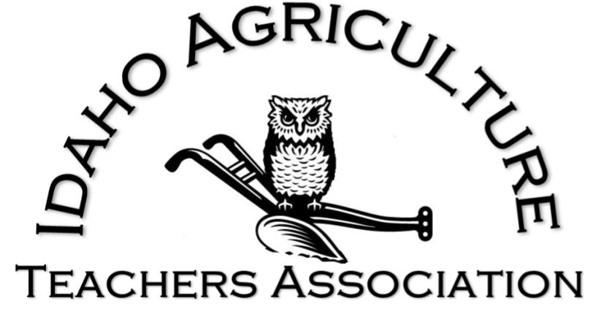
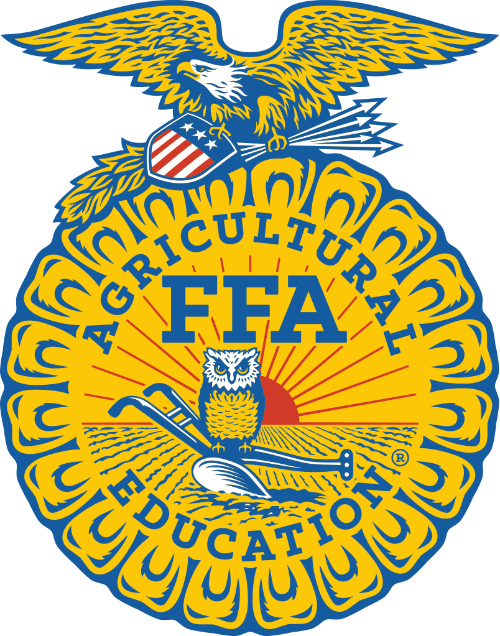

Idaho Ag Teacher Toolbox
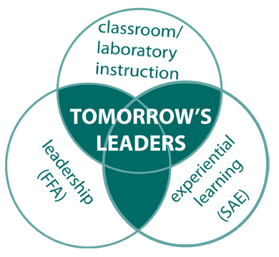
Welcome to Agricultural Education in Idaho! You have selected a very challenging and rewarding career. This guide was created to provide you with basic information to aid you throughout the year. This document is not all-inclusive, but acts as a starting point that will get you going in the right direction. There are references made for contact people in the state that you can call upon for help and get answers to your questions, but know that you can call on any ag teacher for assistance. Our goal is for you to have a great year and wonderful career. We welcome you and look forward to working with you to meet our common goal of enhancing Agricultural Education and the FFA in Idaho.
- IATA Officer Team

Contact Information
IATA Officers
See www.theiata.com/officers for current list
Clara-Leigh Evans
Idaho FFA Executive Director
Go to Clara-Leigh for all things FFA-
including AgCN, applications, events, and National Convention housing.
Email: clevans@uidaho.edu
Phone: 208-253-8813
Ben Meyer
National FFA Organization
Western Region Local Program Success
Specialist
Go to Ben for anything related to
National FFA programs, scholarships, projects, or conferences.
Email: bmeyer@ffa.org
Phone: 317-802-4347 (office)
406-239-1213 (cell)
Dr. Jim Connors
University of Idaho Department of
Agricultural and Extension Education
Professor and Department Head
Go to Dr. Connors for anything related to
parliamentary procedure and UI.
Email: jconnors@uidaho.edu
Phone: 208-885-6358
Lucas Barnett
Idaho Division of CTE
ANR Program Manager
Go to Lucas for state division reports,
annual review, Carl Perkins funding, state funding, IQPS
Email: lucas.barnett@cte.idaho.gov
Phone: 208-429-5510
Jacob Barber
Idaho Division of CTE
ANR Administrative Assistant
Go to Jacob if you can’t reach Mr. Barnett
Email: jacob.barber@cte.idaho.gov
Phone: 208-429-5534
Tammy Ackerland
Idaho Division of CTE
FFA Coordinator
Go to Tammy with any questions about
FFA membership or conference registration
Email: tammy.ackerland@cte.idaho.gov
Phone: 208-429-5502

August:
Classroom/ Lab
- Meet with previous teacher and/or a prominent program supporter to discuss strengths/weakness of the program, how to work with local administration, what works for that school and what does not. Evaluate suggestions and adjust to meet your needs
- Review/ establish grading procedures
- Review/ establish safety procedures and policies
- Review/ revise curriculum
- Check condition of shop tools
- Adjust safety guards and tool rests, change blades, repair welding cables and helmets
- Order shop/ classroom supplies
- Make sure counselor has correct ISEE codes entered for ag classes- click on ISEE Manuals at http://www.sde.idaho.gov/tech-services/isee/
FFA
- Meet with FFA officer team
- Plan FFA retreat/ officer training if applicable
- Email District Advisor for District FFA Calendar
- Prepare a recruitment plans for 1st of the school year.
- Determine National FFA Convention Plans-tours, reservations, etc.
- Plan for National FFA Convention registration- opens in Sept.Recruit for Ag Days (if in fall): Handouts and information available online at http://www.uidaho.edu/cals/agdays
SAE
- Contact members to set up SAE visitations- try and have a parent at the visit and review record books
- County Fair Duties (if applicable)
- Get login information for AET and FFA.org from State FFA Executive Director
Department
- Attend CTE Summer Conference
- Aug. 15th-Tech Prep Reports due in the CATEMA System
- Book rooms and register for NAAE national conference
- Review IQPS requirements and ask questions
- Add yourself to the Idaho Ag Ed Listserv- link on www.theiata.com/resources
- Update Ag Teacher Directory information with University of Idaho Department of Agricultural and Extension Education
September:
Classroom/ Lab
- Order shop/classroom supplies
- Allow students to decorate bulletin boards
- Give Workplace Readiness Assessment (WRA) pretest to all seniors that will be enrolled in ag classes and Technical Skills Assessment pretest to all pathway completers (not required)
- Create one week's worth of emergency sub plans for all classes in case of illness or unexpected absence
FFA
- Start training teams for Soils/ Land Evaluation and Range CDEs
- Develop FFA POA if it hasn’t been accomplished yet
- Meet with local FFA Alumni, parents, supporters to go over yearly calendar
- Finalize National Convention plans, register
- Order FFA jackets if needed
- Help Reporter/ Historian update chapter scrapbook
SAE
- SAE visitations/update record books
Department
- Complete overnight trip requests/ bus requests/ sub requests for the year per school requirements
- Plan for Program Advisory Committee Meeting- set dates, contact individuals, find minutes from last meeting, set agenda
- Register for University of Idaho Ag Ed 560 – Beginning Teacher Induction in Agriculture (if applicable)
- Attend CTE Beginning Teacher Workshop (if applicable)

October:
Classroom/ Lab
- Parent contacts for all struggling students and some outstanding students
FFA
- Oct. 1st
- State Range and Soils Field Day Registration due to the State FFA Executive
Director
- Deadline to declare intent to affiliate for membership purposes
- Finalize sub plans and prepare paperwork for National FFA Convention (if applicable)
- Help students start FFA Agriscience Fair projects (if applicable)
- Help Reporter/ Historian update chapter scrapbook
SAE
- SAE visitations/record book updates
Department
- Oct. 15th
- 10-D Course and Projected Enrollment report due
- Propose any new courses for NEXT school year to school administration/ counselor
- Attend CTE Beginning Teacher Workshop (if applicable)
- Attend October Inservice Days as your district allows

November:
Classroom/ Lab
- Before Thanksgiving- order greenhouse plugs for Mother’s Day sale date
- Apply or recertify greenhouse and/or floral license (if applicable)
- Order greenhouse consumables (plastics, soils, etc) for January delivery
- Order Workplace Readiness Assessment (WRA) (required) and Technical Skills Assessment (if applicable) from CTECS
FFA
- Hand out State Degree Study guide to State Degree candidates- found on www.idahoffa.org
- Have members select Honorary State and American Degree, Distinguished Service, and VIP individuals and fill out applications- due at MidWinter Meeting
- Reserve hotel rooms for 212/360/Day on the Hill
- Help Reporter/ Historian update chapter scrapbook
SAE
- SAE visitations/record book updates
Department
- Nov 1st
- Advisory Committee minutes from previous year (Nov 1st-Oct 31st) due to state CTE office
- Hold fall Advisory Committee Meeting
- Attend NAAE Convention (if applicable)

December:
Classroom/ Lab
- Parent contacts for all struggling students and some outstanding students
FFA
- Dec. 1st
-FFA roster due online
- FFA Program of Activities due to State FFA Executive Director
- Hand out Applications/Sign-ups for 212/360/ Day on the Hill
- Complete applications for Honorary State and American Degree, Distinguished Service, and VIP individuals and turn in to your District Director to take to MidWinter Meeting
- Reserve rooms for SLC in Twin Falls
- Reserve rooms for State CDE’s in Moscow (if not staying in the dorms)
- Help Reporter/ Historian update chapter scrapbook
SAE
- SAE visitations and finalizing record books for calendar year
- Seek out student internship/ placement opportunities for spring SAEs
Department
- Work with school on next year’s registration/ course guide
- Consider applying for and fill out applications for IATA/ NAAE awards

January:
Classroom/ Lab
- Change/update bulletin boards in classroom
- Order vegetable seeds for Mother’s Day Sale date
- Receive delivery and re-order if needed for greenhouse consumables
FFA
- Create a plan for FFA Week
- Find out deadline for and turn in 212/360 registration
- Find out deadline for and turn in Cenarrusa FFA Day on the Hill/Legislative luncheon registration to AMG office in Meridian
- Have seniors work on FFA Scholarship Applications online
- Start planning the end of year banquet
- Start training SLC CDE Teams for open events
- Help Reporter/ Historian update chapter scrapbook
SAE
- Closeout past year record books and open new year record books
- Fill out state degree application
- State Degree Tests and Sifting
Department
- Finalize registration/ course guide information for next school year
- Schedule new student recruitment with Junior High or Middle School
- Register for UI Ag Ed 560 – Beginning Teacher Induction in Agriculture (if applicable)

February:
Classroom/ Lab
- Plant geranium plugs for Mother’s Day sale
- Plant hanging baskets for Mother’s Day Sale- end of February
- Make parent contacts for all struggling students and some outstanding students
- Give Workplace Readiness Assessment (WRA) to all seniors enrolled in ag class during the year
FFA
- Have the following students fill out State FFA applications:
-State officer candidates*
-State FFA Talent*
-State FFA Proficiency candidates*
-FFA Officers- National Chapter*
-FFA Officers- Superior Chapter*
-Sophomores- WLC Scholarship*
- Feb 15th National FFA Scholarships Applications Due
- Conduct activities for National FFA Week
- Help Reporter/ Historian update chapter scrapbook
SAE
- Find out district deadline for and turn in State Degree Applications
- Plan for spring county fair weigh-ins
Department
- Feb 1st
-Kindschy-Lawrence, Riesenberg, & Dirksen Scholarship Apps due to UI AEE for seniors majoring in ag education
- Feb 15th
-10-E Unduplicated Enrollment Report due online for semester based schools (lead instructor only)
-10-SS Summary of Student Status Report due online (CTE Online Administrator only)
- Take a mental health day on a Monday to help reduce stress and relax
- Register for NAAE Region 1 Conference (if applicable)

March:
Classroom/ Lab
- Plant pepper seed for Mother’s Day Sale- highly recommended to use a heating mat
- Plant tomato seeds mid March
FFA
- Beginning of March- promote SLC, create sign-up/ applications
- At FFA meeting, discuss the role of delegates at SLC and select members to represent chapter
- Print off delegate issues packet and allow delegates to review with chapter members
- March 1st
- All applications marked with a * from previous month due to State FFA
Executive Director
- March 15th
- Last day to enroll FFA member eligibility and participation at SLC
- Find out deadline for and submit State Leadership Conference registration
- Find out due date for and submit Job Interview Portfolios, Prepared Public Speaking Manuscripts, and Agriscience Fair (if applicable)
- Help Reporter/ Historian update chapter scrapbook
SAE
- SAE visitations/record book updates
Department
- March 15th
-10-E Unduplicated enrollment report due online for trimester based schools (lead instructor only)
- Register for IATA Summer Inservice

April:
Classroom/ Lab
- Transplant peppers and tomatoes when they reach the true leaf stage
- Make parent contacts for all struggling students and some outstanding students
- Administer Technical Skills Assessments (TSA) for all junior and senior pathway completers (if applicable)
FFA
- Attend FFA SLC
- Hold FFA End of Year Banquet
- Start training teams for State CDE’s in June
- Help Reporter/ Historian update chapter scrapbook
SAE
- SAE visitations/record book updates
Department
- Plan for spring Program Advisory Committee Meeting
- Attend NAAE Region 1 Conference (if applicable)

May:
Classroom/ Lab
- Backup computer files and write down passwords
- Update inventory
- Complete requisition request for next school year
- Complete maintenance request for summer
FFA
- May 1st
- Last day to enroll FFA members for the year
- Find out deadline for State CDE Registration due to UI Department of Agricultural Education and Extension
- Help Reporter/ Historian update chapter scrapbook
SAE
- Meet with administrator about summer contract expectations and plans
- Department
- May 15th
- Local Annual Application due to State CTE Office (provides statement of assurance and budget information)
- Register for CTE Summer Conference
- Submit final PO requests

June:
Classroom
- Clean-up classroom and lab, file papers and organize supplies
FFA
- June 1st
- Annual FFA Chapter Report due to State FFA Executive Director
- American Degree Applications Due to State Executive Director
- Attend State CDE’s in Moscow
- June 30th
- CDE Team Verification Forms due online at www.ffa.org (for teams representing Idaho at Nationals)
- June 30th
- Idaho CTE Foundation scholarship application due for students attending National Convention on a 1st place team
- Plan officer retreat (any time during summer)
- Plan for National Convention housing- contact FFA Executive Director
SAE
- SAE visitations/ record book updates
Department
- Attend IATA Summer Inservice

July:
Classroom/ Lab
- Complete maintenance and repair of shop tools
- Work on curriculum
FFA
- July 1st
- National FFA Convention Band, Chorus, & Talent Applications due to the National FFA Office
-National Chapter Applications and proficiency applications advancing to the national level due to State FFA Executive Director
SAE
- SAE visitations/record book updates
Department
- Complete credit requirements for IATA Summer Inservice (if applicable)

Teacher Strengths – Updated 2018

The following list was created by Idaho agriculture teachers at Summer Conference 2009. Contact information can be found in the Idaho Ag Ed Directory.

Ag Communications
Mike Martin – Marsing
Jeremy Falk – UI
Tom Jacobsen - North Fremont

Ag Mechanics
Jack McHargue – UI, retired
Joe Blackstock – Kuna
Nick Davis - Middleton
Tom Woodland – Gooding
Val Johnson – Madison
Alan Schoen – Rimrock
Vince Wray – Shelley
o Large Engines
Lex Godfrey – Rigby
o Trailer Construction
o Welding
Jesse Miller - Declo
Don Bird – West Jefferson
Ray Shirts – Vallivue
Alan Heikkila - Meridian
Jason Tindall - Ridgevue
Larin Crossley - Preston

Ag Issues Forum
Marc Beitia – American Falls
Tom Jacobsen – North Fremont
Dr. Jim Connors – UI

Agriscience
Jaysa Fillmore – Cassia
Jeremy Falk - UI

Ag Sales
JR Morrow – Genesee
Jason Bair – Madison
Dan Billington-Castleford
Steve Wilder – Meridian
Ray Shirts – Vallivue
Keith Hyatt – Payette – Retired
Nick Davis- Middleton

Agronomy
Shawn Dygert – Kuna
Don Bird – West Jefferson
Mike Tesnohlidek – Fruitland
Jack Blattner- Meridian
Trent VanLeuven- Mackay
Stuart Nesbitt - Wieser, retired

Animal Science
Vince Wray - Shelley
Kattlyn Wolf - UI
Amy Nichols – Cambridge
Joe Blackstock – Kuna
Steve Wilder – Meridian
Liz Russell - Meridian, Equine
Alan Willmore - Jerome

Aquaculture
Matt Wilson – CSI
JR Morrow – Genesee
Jason Bair – Madison
Daniel Knapp – Hagerman
Mike Tesnohlidek – Fruitland
Trent VanLeuven- Mackay

Computer Technology
Nicole Lebsack- Jerome
Jaysa Fillmore - Cassia
Lex Godfrey - Rigby, AET
Casey Zufelt - National FFA
Ben Meyer - National FFA
Dr. Kasee Smith - UI, AET
Cami Schumann - Raft River, AET

Conduct of Meeting
Shawn Dygert - Kuna
Robert Hale - Rigby
Marc Beitia – American Falls

Creed Speaking
Cathy Mosman – Nezperce - parent
Marc Beitia – American Falls
Larin Crossley – Preston

Dairy Cattle
Jim Summers – Westside, retired
Shawn Dygert – Kuna
Larin Crossley – Preston
Vince Wray - Shelley
Dan Billington - Castleford

Dairy Foods
Cody Porath – Kimberly
Tom Clifton – Jerome
Ray Shirts – Vallivue
Mike Tesnohlidek – Fruitland
Kyle Stapleton – Nezperce
Cathy Mosman - parent in Nezperce

Environmental and Natural Resources
Nathan Low – Emmett
Tom Woodland – Gooding
Karen Launchbaugh – UI
Marc Beitia – American Falls
Trish Stokes - Meridian
Sue Poland - Homedale
Jodie Mink - Cambridge
Heather Hendren - Kimberly
Daniel Knapp - Hagerman
Jason Bair - Madison

Extemporaneous Speaking
Cathy Mosman – Nezperce - parent
Shawn Dygert – Kuna
Amy Nichols – Cambridge
Steve Wilder – Meridian
JR Morrow – Genesee

Farm Business Management
Joe Blackstock – Kuna
Robert Hale – Rigby
Larry Church – Payette – retired
Don Bird – West Jefferson
Ray Shirts - Vallivue
Cody Porath – Kimberly

FFA Alumni/Chapter Activities
Alan Heikkila – Meridian
Brian Wolf – Filer
Sid Freeman- Caldwell
Mark Pratt- Idaho FFA Alumni
Ben Meyer- National FFA
Alan Krick - Genesee, Alumni

Floriculture
Leslie Blackburn – CWI
Mike Tesnohlidek – Fruitland
Janna Volkers – Nampa
Sue Poland – Homedale
Jodie Mink- Cambridge
Chance Munns- CSI
Heather Hendren - Kimberly
Brandee Lewis - Shoshone

Food Science and Technology
Tom Woodland – Gooding
Cody Porath – Kimberly
Jodie Mink - Cambridge
Nicole Lebsack- Jerome
Liz Russell- Meridian
Dr. Jeremy Falk- UI
Dr. Brennan Smith - UI

Forestry
Robert Hale - Rigby
Ray Shirts - Vallivue
Travis Edwards - Kuna
Troy Wright - Fruitland
Tom Woodland - Gooding
Nicole Lebsack - Jerome
Val Johnson - Madison

Horse
Joe Burrie – Malad , retired
Lori Idsinga – Homedale – Idaho FFA
Robert Hale – Rigby
Travis Edwards – Kuna
Billie Jo Blackson - Technical Careers HS
Liz Russell - Meridian

Horticulture/Greenhouse
Jeff Gerard – Hansen, retired
Robert Hale – Rigby
Mike Tesnohlidek – Fruitland
Bill Dean – Emmett, retired
Jason Bair – Madison
Shawn Dygert – Kuna
Daniel Knapp – Hagerman
Trent VanLeuven - Mackay
Chance Munns - CSI

Job Interview
Jason Bair – Madison
Kyle Stapleton – Nezperce
Jack Blattner – Meridian
Katie Mosman - Grangeville

Livestock
Joe Blackstock – Kuna
Steve Wilder – Meridian
Troy Wright – Fruitland
Daniel Knapp – Hagerman
Joe Maxwell- Kimberly
Shane Wetzel - Madison

Marketing Plan
Jeff Gerard – Hansen, retired
Mike Martin – Marsing
Trent VanLeuvan – Mackay
Marc Beitia - American Falls

Meats
Jack Blattner – Meridian
Joe Blackstock – Kuna
Robert Hale – Rigby
Mike Tesnohlidek – Fruitland
Tom Woodland – Gooding
Brian Wolf - Filer
Troy Bird - Minico
Stacie Reid - Potlatch

National Chapter
Marc Beitia – American Falls
Shawn Dygert – Kuna
Heather Hendren – Kimberly
Sue Poland - Homedale, retired
Steve Wilder - Meridian

Nursery
Robert Hale – Rigby
Nick Davis – Middleton
Trish Stokes – Meridian
Jodie Mink- Cambridge

Parliamentary Procedure
Joe Blackstock – Kuna
Steve Wilder – Meridian
Dr. Jim Connors – UI
Jack Blattner – Meridian
Val Johnson – Madison
Robert Hale – Rigby
Tom Clifton – Jerome
Carl Perkins Law and Funding
Josie Chancey – CTE
Val Johnson – Madison
Shawn Dygert- Kuna

Prepared Public Speaking
Jim Summers – Westside, retired
Larin Crossley – Preston
Alan Heikkila – Meridian
Steve Wilder – Meridian
Dr. Katllyn Wolf - UI

Proficiency Awards
Shawn Dygert - Kuna
Lex Godfrey – Burley
Sue Poland - Homedale, retired

Range
Shawn Dygert – Kuna
Karen Launchbaugh – UI
Tom Woodland – Gooding
Cody Porath – Kimberly
Daniel Knapp – Hagerman
Sue Poland - Homedale, retired
Jodie Mink - Cambridge

Recordbook/State Degree
Lex Godfrey – Rigby
Shawn Dygert – Kuna
Brian Wolf – Filer

Scrapbook
Heather Hendren – Kimberly
Marc Beitia – American Falls
Sue Poland - Homedale, retired
Jodie Mink - Cambridge

Small Engines
Alan Heikkila – Meridian
Ray Shirts – Vallivue
Randy Hillman – South Fremont
Jack McHargue – UI, retired
Joe Blackstock – Kuna
Don Bird – West Jefferson
Vince Wray – Shelley
Alan Schoen - Rimrock

Soils
Lex Godfrey – Rigby
Tom Woodland – Gooding
Shawn Dygert – Kuna
Larin Crossley - Preston
Don Bird – West Jefferson
Larry Church – Payette , retired
Anita Falen – UI
Kyle Stapleton - Nezperce
JR Morrow - Genesee
Tom Clifton - Jerome
Sam Hoffman - Troy

Structures/Woods
Ron Corbett – Council
Harley Wilson – Middleton
Kyle Stapleton – Nezperce
Val Johnson - Madison

Trailers/Metal Fab
Lex Godfrey – Rigby
Zebbie Miller – Shelley, retired
Jesse Miller – Declo
Keith Hyatt – Payette , retired
Jason Tindall – Ridgevue
Val Johnson - Madison
Harley Wilson - Middleton

Welding
Brian Wolf – Filer
Lex Godfrey – Rigby
Alan Heikkila – Meridian
Jesse Miller – Declo
Jack Blattner – Meridian
Val Johnson – Madison

Vet Science
Janna Volkers - Nampa
Brian Wolf - Filer
Steve WIlder - Meridian
Heather Hendren - Kimberly

Team Ag Ed Structure
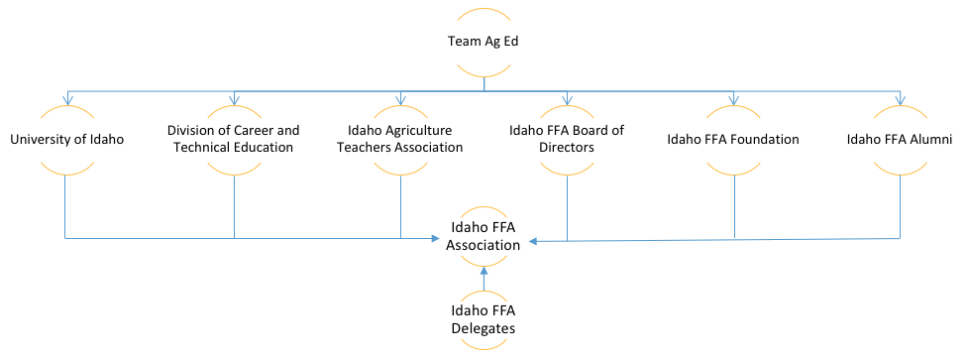
Helpful Links

Program Management
- Idaho Division of Career and Technical Education: http://www.cte.idaho.gov
- Idaho State FFA CDE Rules and Policies:
- http://www.uidaho.edu/cals/agricultural-and-extension-education/agricultural-educators/career-development-event
- Idaho State Department of Education Certification/ Re-certification web page: http://www.sde.idaho.gov/site/teacher_certification/
- Idaho Ag Ed List-Serve/email distribution: https://lists.uidaho.edu/mailman/listinfo/idahoaged to sign up, idahoaged@uidaho.edu to send
- Idaho Ag Teacher Directory: https://www.uidaho.edu/cals/aee Click on “Agricultural Educators” and “Idaho Teacher Directory”

Associations
- NAAE: http://www.naae.org/index.cfm
- ACTE: https://www.acteonline.org/
- CTEI: http://www.ctei.org/
- IATA: http://theiata.com
- Idaho FFA: http://www.idahoffa.org

Curriculum
- Communities of Practice: http://communities.naae.org/welcome
- Idaho Ag Ed Curriculum: https://www.uidaho.edu/cals/agricultural-and-extension-education/agricultural-educators/curriculum-guides
- FFA.org My Journey: https://www.ffa.org/my-journey
- UI Range Website:
https://idahorange.wordpress.com/
- UI ENR Website:
https://idahorange.wordpress.com/

