Herd: A herd code number uniquely identifies each herd. The herd number consists of eight digits. The first two digits identify the state in which the herd is located. The second two digits identify the county or the association in some states. The last four digits identify the herd within the county.

String: When a herd is divided into permanent strings, the string number is printed in the STR box.

The following dates are printed on the Monthly Cow List:
- Current Date of Test
- Received at DHI
- Report through
- Date Mailed

Type of Record: A short description of the type of DHIA record plan the herd is using is printed in this box.

Base ME/ Relative Value: Depending in the relative value option requested, an average is computed for the herd on a 305-date mature equivalent basis. The relative value option the producer has selected is also printed.

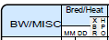

Body Weight/ Miscellaneous:

This column is a user-defined field controlled by an option in the Report Selection and Control section of the Herd Barn Sheet. There are three different types of data which can be printed in this column:

- Body Weight or miscellaneous
  - The body weight of a cow expressed in 100 pounds, usually recorded at time of calving. If no body weight is recorded when a cow enters a herd, it is estimated based on lactation number.
- Somatic Cells
  - A count of the white blood cells in a milliliter of milk. A normal count is generally considered to be 100,000 or less. SCCA represents the somatic cell count expressed as the actual count to the nearest 1,000 and not a linear count. SCCS indicates the value is expressed as a linear score.
- Last Service Sire
  - The sire used in the last breeding
Bred/ Heat:
The last breeding or date the cow was seen in heat is expressed in MM/DD format
XBR:
Number of times that animal has been bred during the current lactation.

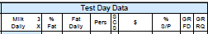

Milk Daily: Milk production in a 24-hour period. A cow may be milked from one to several times in this period of time. Milk is recorded in pounds to nearest tenth of a pound as 39.6.

3x: Will be marked if the herd is milked three times a day.

% Fat: The percent of fat in the milk, calculated by fat lbs./ milk lbs. X 100

Fat Daily: How many pounds of fat is produced in a 24 hour period.

Persistency: The persistency of a cow’s production is an indication of her production (3.5% FCM) on test day compared to the previous test day production (3.5% FMC). Indexes over 100 indicate increasing production while less than 100 indicate drops in production. Cows normally will increase production for about 60 days after calving and decrease about 10% per month after 90 days.

Somatic Cell Score: This is a linear score that is assigned based upon the raw count and has a direct relationship to milk loss. The table below shows the relationship to milk loss. The milk loss is based on second or greater lactation animals. First lactation animals would have half of the loss listed.
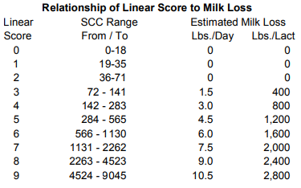
$: The Merit value (Net, Cheese or Fluid) that estimates the additional net profit that an offspring of an animal will provide during its lifetime. The measure adjusts for both income and expenses for a typical dairy operation to produce a measure of overall net profit. The primary difference between the three formulas for merit is the emphasis that is placed on the components. Producers should select the index that is closest to the milk payment in their area.

% S/P: If a herd is testing for Protein or SNF, the percent is printed in this column. The percent of protein in the milk, calculated by protein lbs./milk lbs. X 100.

GRFD: Grain Fed, Grain requirements are estimated for the daily production of each cow

GRRQ: Grain Required, Grain requirements are estimated for the daily production of each cow
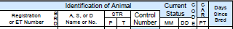

Registration or ET Number: Unique number listed on a registered animal’s registration certificate. The registration (or eartag) and breed identification are printed for each cow. If the cow is registered, an asterisk (*) is printed to the right of the breed identification.

Breed: One of the recognized breeds of dairy animals. If the breed of the sire and dam are different, the animal is designated a crossbreed.
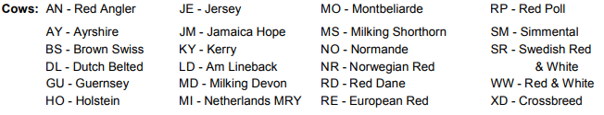

Animal, Sire or Dam Name or Number: Producer chosen section to add the names or numbers if desired.

String, Permanent and/or Temporary: If a herd is using strings to group animals, the string numbers are printed in the appropriate boxes. They can be used to sort this report within string groups.

Control Number: This is the individual animals ear tag/ Identification number.
Current Status: The status date of each animal is printed in this column. The status code printed to the right of the status date identifies the status of the animal as follows:

- Cow Freshened
- Heifer Freshened
- Cow Entered Herd Dry
- Cow Entered Herd in Milk
- Cow Aborted
- Cow Turned Dry
- Cow Sold for Dairy
- Cow Sold for Beef
- Died

CAR (P/T) Conditions Affecting Record: If a code is in the PCAR column, this indicates an event occurred to seriously affect the record. If the code is in the TCAR column, the event affected the record temporarily or for a short duration. Codes used to provide specific information about the cow’s record or the current milk weight or component test. The following codes are used when an animal is reported as leaving the herd:
- Sold Feet and Legs | 6- Died
- Sold Dairy | 7- Sold Mastitis
- Sold Low Production | 8- Sold Disease
- Sold Reproductive Problems | 9- Sold Udder
- Sold Injury or Other | X- Sold, reason not reported
The following CAR codes indicate something about the current test day’s milk weight or component test and are only printed if the information is estimated.
- Abnormal weights were recorded
E- Estimated, no weights were recorded
F- Fat % and Protein % were estimated, no sample collected by technician
H- In heat on test day
- Injected prior to or during milking

L- Fat% and Protein % estimated, Lab unable to get results from sample.

Days Since Bred: The days since bred is printed in this column. If a cow is open 21 days (one heat period) over the option requested on the Herd Barn Sheet, an asterisk (*) is printed on the right side of the Days Since Bred column.
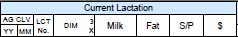

Age at calving: Age the animal was when they gave birth to their most recent calf. Reported in Years then months.

Lactation number: The number of times a cow has calved. If no lactation number is recorded when a cow enters the herd, a lactation number is estimated based upon the age of the animal.

Days in Milk: Number of days from calving date to dry date (Days in Milk = dry date - calving date). If a cow is still milking, the days in milk is computed as the number of days from calving through the date of test (including both dates). That is, (Days in Milk = date of test + 1 day - calving date).
- If a cow is milked three times a day at any time during her lactation, an asterisk (*) is printed to the right of the days in milk.

Milk: Total pounds of milk produced during current lactation.

Fat: Total pounds of fat produced during current lactation.

Solids non-fat/ Protein: Total pounds of non-fat solids or protein produced during current lactation. Usually this column reports protein but can be chosen as SNF if the producer chooses.

$: If the value of product option is being used the value of product for the lactation is printed based on the relative value option.

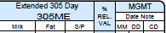

A 305 ME (mature equivalent) or a 305 Actual Extended record is printed for each cow based on pounds of milk, fat and protein/SNF for this lactation.

305 ME: By the use of special factors the lactation is adjusted for days in milk, milking frequency, season of calving, location and age to that of a mature cow. Unless the cow is mature or milked 3X, the M.E. Lactation will be larger than the actual 305 day lactation record.

Percent Relative Value: The percent relative value is the percentage the cow is above or below other cows in the herd, with 100 being herd average. All cows are compared on a mature equivalent basis. If a cow’s % REL VAL was 130, she would be 30% above the herd average. The relative value is recomputed will more accurately estimate the completed 305 lactation (M.E.).

The management date and note code is printed in this column based on the option selected by the producer. The following management codes are used:
# - 305 day record
[] – Completed record
B – Cow should be bred at next heat period after reported date
D – Cow should calve on date reported if last breeding is correct
DD- Dry date passed
CM – Calving Imminent
