Jerome

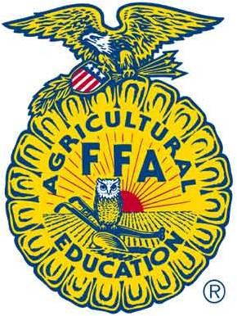

FFA

2017-2018
Student Handbook

2016-2017
CDE Results
District State Nationals
Agricultural Mechanics 2nd 32th
Agricultural Sales 3rd
Agronomy 1st 5th
Creed Speaking 4th
Dairy Cattle Evaluation
Dairy Food Products 1st 1st 7th
Dairy Handling 3rd
Extemporaneous Speaking 1st
Food Science 1st 6th
Forestry 1st 4th
Greenhand 2nd
Horse Evaluation 3rd 18th
Job Interview 3^{rdt}
Livestock Evaluation 4th 39th
Opening/Closing 1st
Parliamentary Procedure 1st
Prepared Public Speaking 1st 1st
Soil and Land Evaluation 1st
Table of Contents

- Chapter Information
  - Chapter Advisors and Officers
  - Get Involved!
    - Meetings/Committee’s
    - Career Development Events
    - Supervised Agricultural Experience (SAE’s)
    - Leadership Conferences
    - Community Service
  - Point Awards
  - Jerome FFA Constitution
- General FFA Information
  - Mission and Motto
  - Creed
  - Emblem
  - Official Dress
    - How to Order Your Jacket
  - Degree Program
  - Idaho FFA Districts
- Calendar

Advisors
Mr. Clifton
Email: tom.clifton@jeromeschools.org
Phone: 208-539-6325
Mrs. Lebsack
Email: nicole.lebsack@jeromeschools.org
Phone: 208-420-7309
Mr. Willmore
Email: alan.willmore@jeromeschools.org
Phone: 208-589-8210
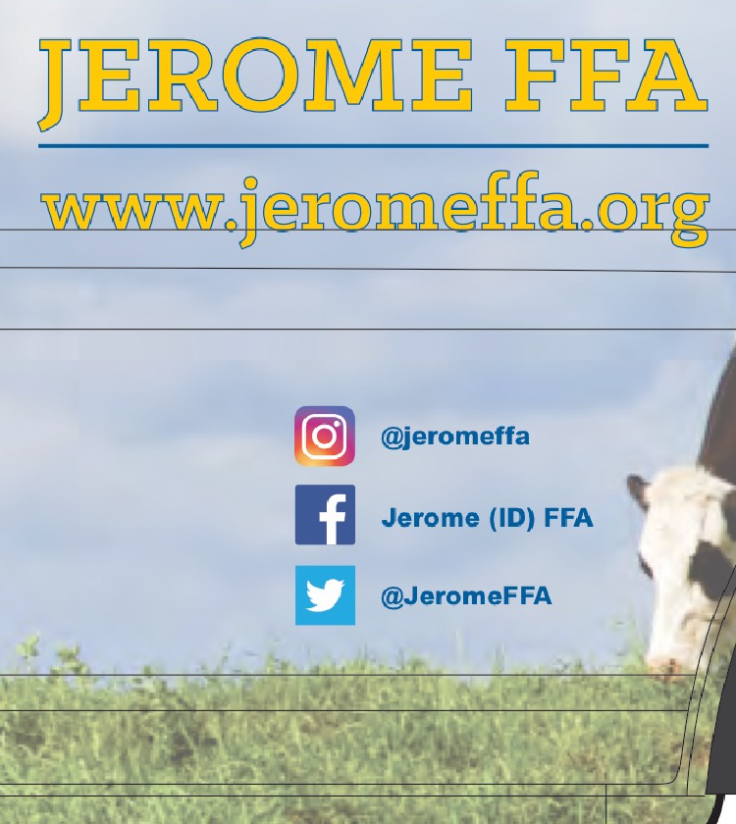

Officers
Historian-Troy Larsen
Sentinel-Alyssa Hansten
Reporter-Adri Larsen
Treasurer-Maddie Johnson
Secretary-Cody Jackson
Vice President-Annabelle Day
President-Kaitlin Mirkin

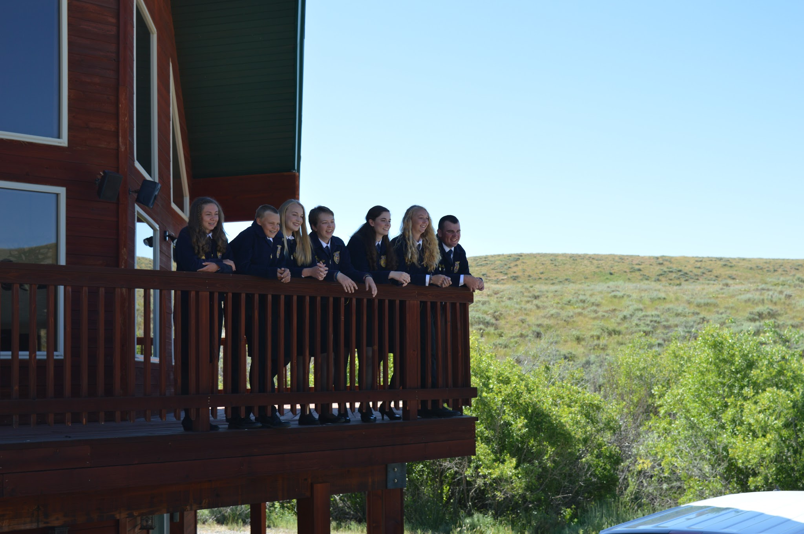

8 ways to GET INVOLVED!

- Attend Chapter Meetings

Chapter FFA meetings will be held on the 1st Tuesday of each month in Room 401 in the Agricultural Department at 6:00pm.

- Serve on a Committee

Help plan FFA activities by serving on or even chairing a committee. Committee meetings will be held during each general meeting with special meetings called at lunch. Our committees:
Growing Leaders
Strengthening Agriculture
Building Communities

- Participate in Career Development Events

Career development events are activities that allow students to learn more about agricultural areas they are interested in. That knowledge is put to the test when students get the opportunity to challenge themselves in industry based competency exercises in a variety of agriculture and leadership scenarios.

Jerome competes in 19 CDE’s; to participate, simply sign up in the lobby and the Advisor in charge will contact you regarding practice times. Most teams require a try-out to determine an official team, however, alternates can be taken to most events. Below are short descriptions of each of the CDE’s and months when practices usually start.

Agricultural Mechanics
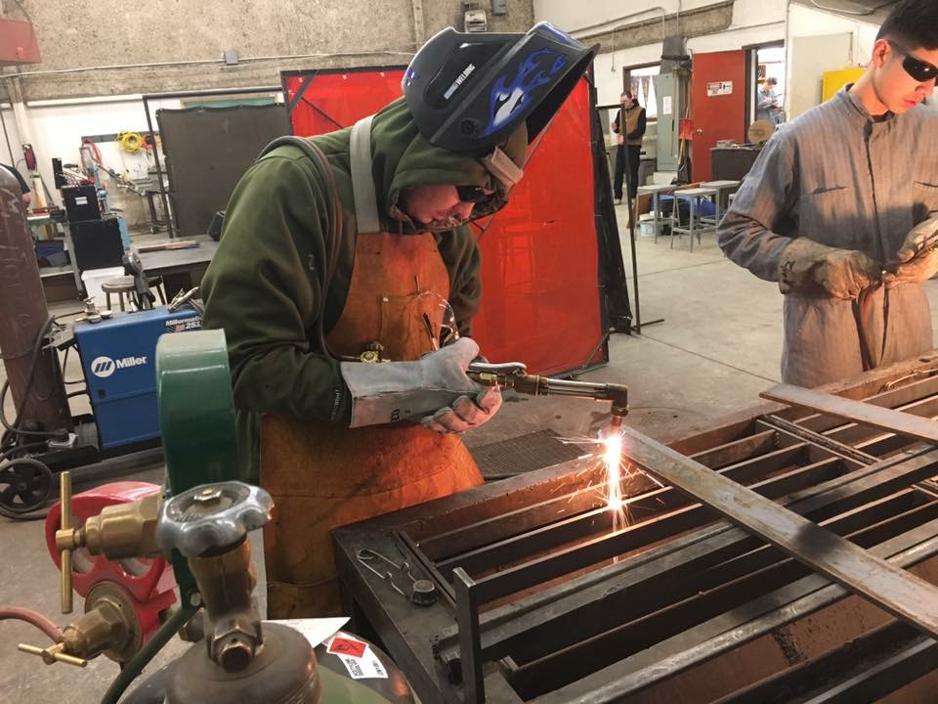
A 4 person team with each student participating in two of the following areas: Arc Welding, Oxyacetylene Welding, Tool and Hardware Identification, Tool Reconditioning/Metal Identification or Pipe Fitting, Electricity, or Small Gasoline Engines. Practice for district CDE starts in January.

Agricultural Sales
A team consists of 4 individuals, where 2 students will do a sales presentation and the other two will participate in either telephone skills, customer prospecting or customer relations. Practice for the District CDE starts in December.

Agronomy
A team consists of 4 members. Each member has to identify different seed and plant samples, insects and disorders of plants, and solve a fertilizer problem or seed analysis. Practice for the District CDE starts in November.

Conduct of Meeting
Each team will consist of 7 members in the 8th and 9th grade. Members will fulfill the duties of president, vice president, secretary, treasurer, reporter, sentinel and advisor. Practices for District CDE will start in March.

Creed Speaking
Each chapter can send one student to compete at the district level. The student must recite the FFA creed. Practice for the District CDE starts in October.

Dairy Cattle Evaluation
A 4 person team. This CDE emphasizes skills in dairy cattle evaluation, selection and dairy herd management. Practice for the District CDE starts in March.

Dairy Food Products
4 participants will identify cheese, evaluate the flavor quality of milk, distinguish between dairy and non-dairy products, and complete a written test on milk production and marketing. Practice for the District CDE starts in November.

Extemporaneous Public Speaking
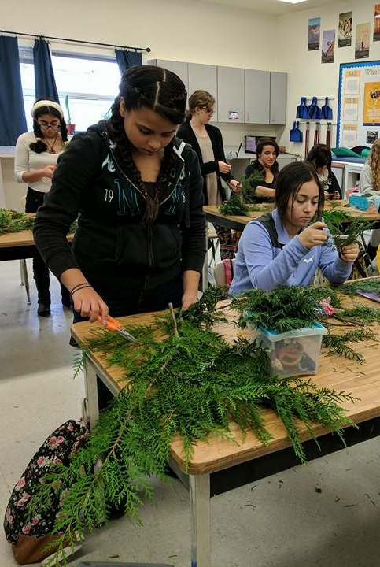
Each chapter can send one student to the District CDE. A student will draw a topic and will have 30 minutes to prepare a 4-6 minute speech. Practice for the District CDE will start in February.

Floriculture
A team will consist of 4 individuals. Students will have to identify plant/flower species, solve problems related to the floral industry, take a general floriculture examination, complete a floral arrangement practicum, and create a $25 floral arrangement. Practice for the District CDE will start in February.

Food Science
The Food Science and Technology CDE requires students to have an in-depth understanding of food product development and presentation and food safety issues. Participants use their sensory skills to solve problems and make sound decisions. Practices for the District CDE will start in January.

Forestry
A 4 member team will demonstrate skills in timber cruising, log scaling, tree identification, tool identification, compass and map reading. Practices for District CDE will start in March.

Greenhand
Freshmen take an FFA based knowledge test. Talk to Lebsack for study material in September.

Horse Evaluation
Four students evaluate and rank horses based on breed characteristics, conformation and performance. As a team, students cooperatively solve problems related to equine selection, management, nutrition and production. Practices for the District CDE start in March.
Job Interview
Each chapter may send one student to the District CDE. The student will submit a resume, cover letter, and job application. Participate in a mock job interview and then write a follow-up letter. Practices for the District CDE start in October.

Livestock Evaluation
Four participants will constitute an official team. This CDE emphasizes skills in livestock evaluation, selection, and herd management. Practices for the District CDE start in September.

Meats
Four students make up the team. During the event, members evaluate beef carcasses for quality and yield grade; identify various meat cuts and place carcasses, and identify wholesale and/or retail cuts. Practices for the District CDE start in April.
Opening/Closing
A team consists of the Officer team. The team will perform the opening and closing ceremonies for an FFA meeting. Practices will begin in October.

Parliamentary Procedure
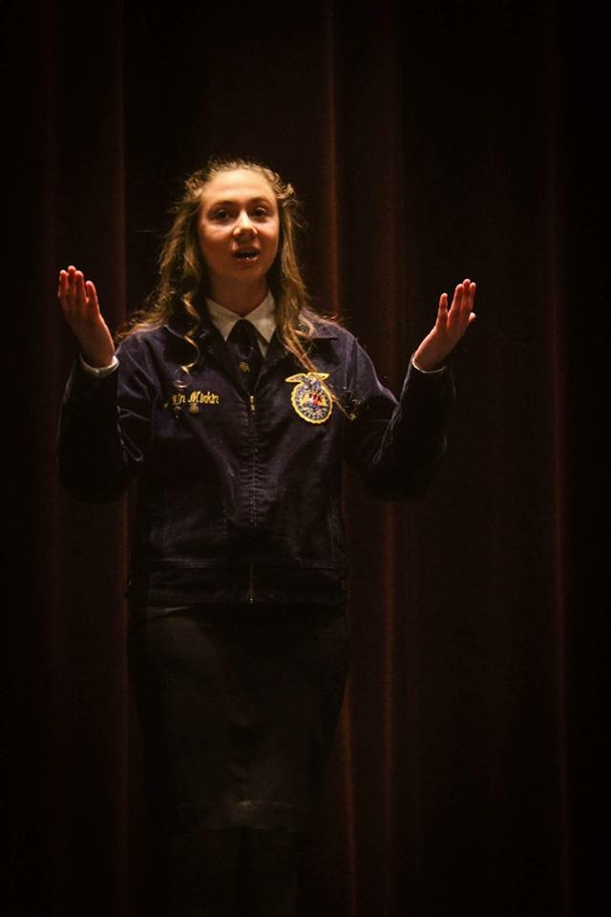
A team will consist of 6 FFA members. They will use parliamentary procedure to conduct an orderly and efficient meeting and take a written exam on parliamentary procedure. Practices will begin in February.

Prepared Public Speaking
Each chapter may send one student to the District CDE. The student will conduct research on an agricultural topic, write a manuscript, and deliver a prepared speech. Practices will be intermittent throughout the year.

Soil and Land Evaluation
A team will consist of 4 individuals. The participants will identify physical features of the soil, determine land capability for crop production, and evaluate management practices. Practices will begin in September.

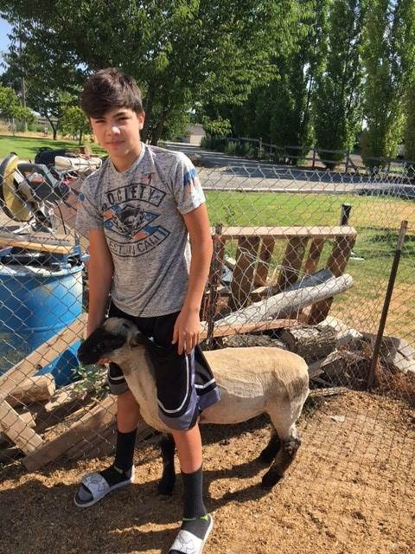
- Start a Supervised Agricultural Experience Project (SAE)

Students with an SAE learn by doing. With help from their agricultural teachers, students develop an SAE project based on one or more SAE categories.

Entrepreneurship
Own and operate an agricultural business (e.g. a lawn care service, a pay-to-fish operation, Livestock animals, holiday poinsettia production and sales.)
Placement
Get a job or internship on a farm or ranch, at an agriculture-based business, or in a school or factory laboratory.

Research and Experimentation
Plan and conduct a scientific experiment. (e.g. determine whether the phases of the moon affect plant growth, or test and determine the efficacy of different welding methods.)

Exploratory
Explore careers in agriculture by attending an agriculture career fair, or creating a report or documentary on the work of a veterinarian.

- Pay FFA Dues

Dues must be paid by November 1st to qualify for FFA awards, degrees, scholarships, attendance to Leadership Conferences, and to receive the New Horizons magazine. Dues are $20 and cover most CDE’s and local activities.

- Attend Leadership Conferences

Ag Days
Experience the University of Idaho. Friday attend workshops about agriculture, leadership, and U of I academics. On Saturday participate in Dairy Cattle Evaluation, Livestock Evaluation, or Parliamentary Procedure CDE’s.

212/360
212 degrees is temperature at which water boils. At 211° water is extremely hot, but just one more degree takes up another level and changes its state. The 212° conference challenges students to push past their limits to the boiling point of leadership.
360° takes students full circle through chapter leadership development. Attendees will learn how to develop action plans for their chapters from every angle. Themes for this conference are action and influence.

State Leadership Conference
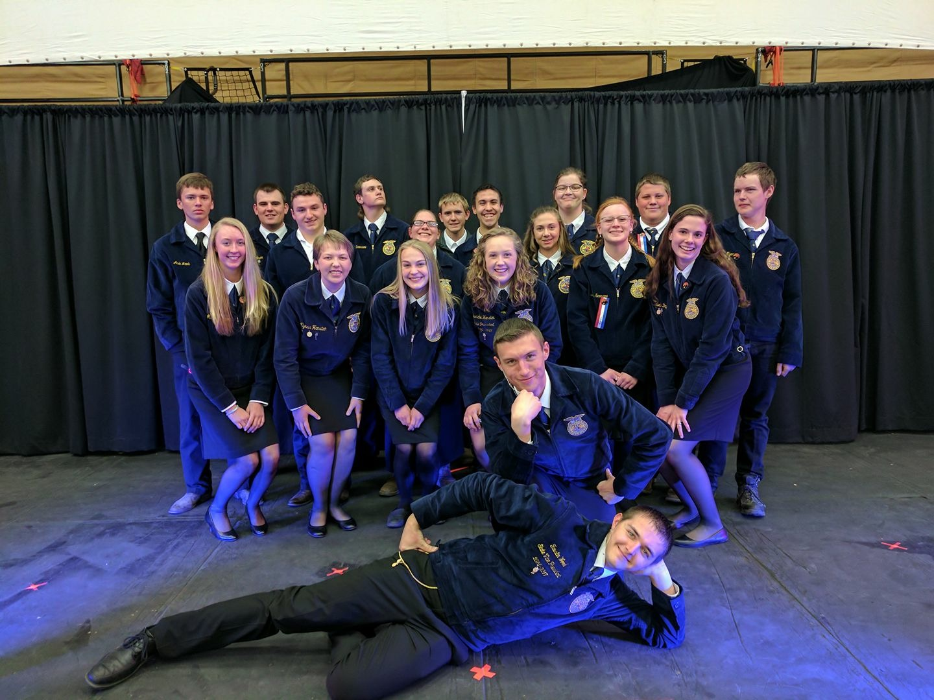
State Leadership Conference (SLC) is Idaho's premier leadership event for FFA. SLC is four days of leadership workshops, career development events, motivational speeches, and awards for the top FFA members in Idaho. Attendance at the conference tops 1,500 each year. The College of Southern Idaho in Twin Falls is the annual host of SLC.

National FFA Convention
The national FFA convention is held each October with nearly 55,000 FFA members and guests from across the country in attendance. Members participate in general sessions, competitive events, educational tours, leadership workshops, a career show and expo, volunteer activities and much more. It is one of the largest annual student conventions in the country.
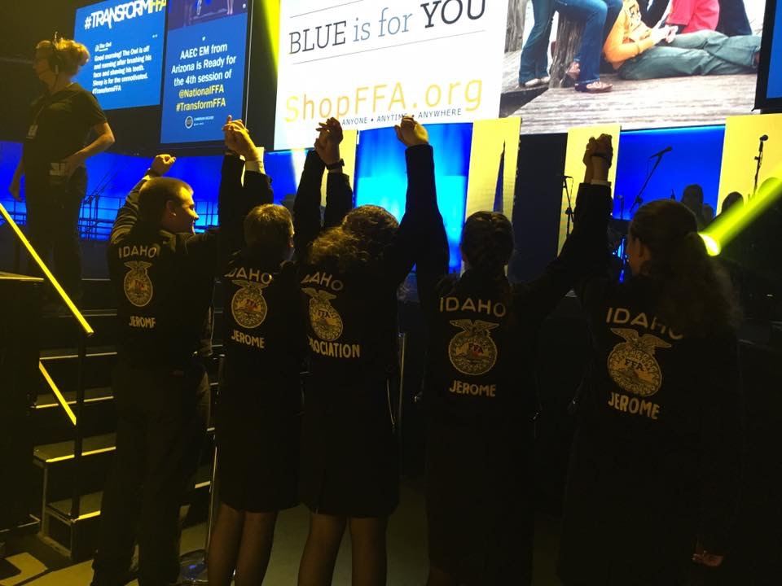
WLC
WLC is the ultimate leadership experience for FFA members. It provides hands-on experiences that help attendees learn how to apply leadership skills to real-life situations. This conferences focuses on personal development, diversity, advocacy and service. There are seven, one-week sessions each summer.

- Community Service

The National FFA Organization embraces the idea of giving back to our communities. The last line of the motto "Living to Serve", signifies the vital role service plays in our organization.
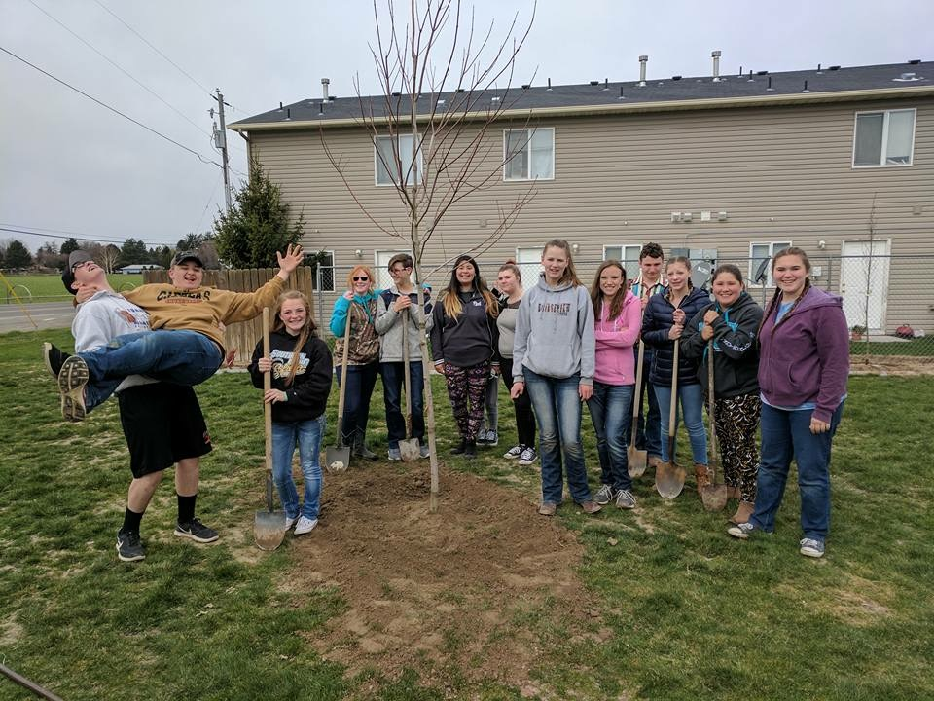
Projects can be completed individually, small groups, or with the entire chapter. Keep track of your hours and take pictures of you and/or your group doing the project and submit them to Mr. Clifton or Mrs. Lebsack. Better yet announce what you are doing at the General FFA meeting to get everyone involved in your community service.

8) Take and Animal To Fair

Raise a livestock animal, keep your AET record book up to date, attend fair decorating day/take down day, serve at the FFA Buyers Breakfast, and attend at least 5 FFA meetings and you can take a livestock animal to the Jerome County Fair!

PointAwards

Throughout the year the FFA officers keep track of each members involvement in the FFA and awards the students points. At the end of the year the 10 students with the most points gets to go on a point awards trip.

Meetings
- FFA Chapter Meeting………………………….5
- FFA Uniform at meeting……………………….5
Activities
- Other FFA Event……………………………….10
- Community Service Hours…………………….10
- Top Salesman…………………………………..15
FFA Degree
- Greenhand or Chapter………………………...10
- State Degree…………………………………..50
Leadership
- Apply for Chapter Office…………………..…20
- Apply for District Office……………………...25
Conferences
- Ag Days……………………………………….20
- 212/360………………………………………..20
- State Leadership………………………………20
Teams
- District Team Member………………………..10
- Alternate………………………………………..5
- 1st Place Team…………………………………25
- Individual Placing’s
1st……………………………………….…25
2nd………………………………………...20
3rd…………………………………………15
4th………………………………………....10
5th………………………………………......5
Public Speaking
- Local (if applicable)……………………………10
- District…………………………………………25
- State………………………………………… …50

Jerome FFA Constitution

Article 1-Name and Purpose
Section A. The name of this organization shall be the Jerome Chapter of the FFA.
Section B. The purposes for which this chapter is formed are as follows:
- To develop competent, assertive, rural, and agricultural leadership.
- To create and nurture a love of country life.
- To strengthen the confidence of students in themselves and their work.
- To create more interest in agriculture occupations.
- To encourage members to improve the agriculture industry and its surroundings.
- To encourage members in the development of individual agriculture programs and establishment in farming.
- To participate in worthy undertakings for the improvement of agriculture.
- To develop character, train for useful citizenship, and foster patriotism.
- To participate in cooperative effort.
- To encourage and practice thrift.
- To encourage improvement in scholarships.
- To provide and encourage the development of organized rural recreation activities.

Article II-Organization
Section A. The Jerome Chapter of the FFA is a chartered local unit of the Idaho Association of FFA which is chartered by the National Organization of FFA.
Section B. This chapter accepts in full the provisions in the constitution and bylaws of the Idaho Association of FFA as well as those of the National Organization of the FFA.

Article III-Membership
Section A. Membership in this chapter shall be of three kinds 1) Active, 2) Associate, and 3) Honorary, as defined by the National FFA constitution.
Section B. Honorary membership in this chapter shall be limited to the Honorary Chapter FFA Degree.
Section C. Active members in good standing may vote on all business brought before the chapter. An active member shall be considered in good standing when:
- She/he attends local chapter meetings with reasonable regularity.
- She/he shows an interest in and takes part in the affairs of the chapter.
- She/he pays dues regularly.
Section D. Names of applicants for membership shall be filled with the secretary.

Article IV-Emblems
Section A. The emblem of the FFA shall be the emblem of this chapter.
Section B. Emblems used by the members shall be designated by the National Organization of FFA.

Article V-Membership Degrees and Privileges
Section A. There shall be four degrees of active membership in this chapter. These degrees are: 1) The Greenhand Degree, 2) The Chapter Degree, 3) The State Degree, and 4) The American Degree. All “Geenhands” are entitled to wear the regulation bronze emblem pin. All members holding the degree of Chapter FFA are entitled to wear the silver emblem degree pin. All members holding the State FFA Degree are entitled to wear the regulation gold emblem charm. All members holding the American FFA Degree are entitled to wear the regulation gold emblem key.
Section B. Greenhand Degree
Minimum qualifications for election:
- Be regularly enrolled in a class in agricultural education and have satisfactory and acceptable plans for an SAE.
- Be familiar with the purposes of the FFA and the program of work of the local chapter.
- Know the FFA creed and what it stands for.
Section C. Chapter FFA Degree
Minimum qualification for election:
- Must have held the Degree of the Greenhand for at least one year immediately preceding election to the Degree of the Chapter FFA and have a record of satisfactory participation in the activities, at least one contest in the preceding year, of your local chapter.
- Must have satisfactory completed at least one year of instruction in agricultural education, have in operation an approved SAE, and be regularly enrolled in an agricultural education class.
- Be familiar with the purposes and programs of work of the State Association and National Organization.
- Be familiar with parliamentary procedure.
- Be able to lead a group discussion for fifteen minutes.
- Must have earned by his/her own efforts from his/her SAE and deposited in a bank or otherwise productively invested at least $50 or 50 hours.
- Receive a majority vote of the members present at a regular local chapter meeting.
Section D. State FFA Degree
Minimum qualifications for election:
- Qualifications are those set forth in the Constitution of the State Association.
Section E. American FFA Degree
Minimum qualifications for election:
- Qualifications for the American FFA Degree are those set forth in the Constitution of the National Association of the FFA.
Section F. Special committees shall review the qualifications of members and make recommendations to the chapter concerning degree advancement.

Article VI-Officers
Section A. The officers of the chapter shall be as follows: President, Vice-President, Secretary, Treasurer, Reporter, Sentinel, and Advisor/s. The advisors shall be the teachers of agricultural education in the school where the chapter is located. Officers shall perform the usual duties of their respective offices. The chapter may elect additional offices as needed.
Section B. Officers shall be appointed by the sifting committee, selected by the executive committee.
Section C. The officers of the chapter, shall constitute the Chapter Executive Committee. The Executive Committee shall have full power to act as necessary for the chapter in accordance with actions taken at chapter meetings and various regulations or bylaws adopted from time to time.
Section D. Honorary members shall not vote nor shall they hold any office in the chapter except that of Advisor.

Article VII-Meetings
Section A. Chapter meeting shall be held at least nine times during the year at such time and place as is designated by the chapter executive committee. Special meetings may be called at any time. Executive meeting will be held prior to each chapter meeting and other times as deemed necessary.
Section B. Standard meeting paraphernalia shall be used at each meeting. All regular meetings shall open and close with official ceremony. Parliamentary procedure shall be used in transacting all business at each meeting.
Section C. Delegates, as specified by the State Constitution, shall be elected annually from the active membership to represent the chapter at the State Convention. Other delegates may be named as necessary in order to have proper representation at various other FFA meetings within the state.
Section D. A majority of the active members listed on the secretary’s membership roll shall constitute a quorum, and a quorum must be present at any meeting at which business is transacted or a vote taken committing the chapter to any proposal or action.

Article VIII-Duties of Members
Section A. Members should attend meetings and activities as regularly and promptly as possible.
Section B. Members must refrain from drinking, smoking, or chewing on or at any FFA activity or function.

Article IX-Dues
Section A. Local dues in this chapter shall be fixed annually by the executive committee.
Section B. Full local, state, and national dues shall be paid by all active members.
Section C. No member shall be considered as active and in good standing unless he/she pays full local, state, and national FFA Dues.

Article X-Senior Cord and Sash Requirements
Section A. To be eligible to receive the Jerome FFA cord, a member must meet the following minimum qualifications:
- Must have received the Jerome FFA Chapter FFA Degree.
- Must have satisfactorily completed the equivalent of at least 210 hours of systemic school instruction in the agriculture education at or above the ninth grade level, have in operation an approved supervised agriculture experience program and be enrolled in an agriculture course.
- Have participated in the planning and conducting of at least three official functions in the chapter’s program of activities.
- A student after entering agricultural education must have earned and productively invested at least $1,000 or worked at least 500 hours in excess of scheduled class time or a combination thereof, in supervised agriculture experience program.
- Have effectively led a group discussion for 15 minutes.
- Have demonstrated three procedures of parliamentary law.
- Has participated in at least 3 Career Development Events at the district/state level.
- Have participated in at least 25 hours of community service activities. These hours are in addition to and cannot be duplicated as paid or unpaid supervised agriculture experience hours.
Section B. To be eligible to receive the Jerome FFA Sash, a member must meet the following minimum qualifications:
- Have received State FFA Degree
- Have been an active FFA member for at least 4 years at the time of receiving the state FFA Degree.
- While in school have completed the equivalent of at least three years of systemic school instruction in agriculture education at or above the ninth grade level, which includes a supervised agriculture experience program.
- A Student after entering agricultural education must have
  - Earned and productively invested at least $1,000
  - Worked at least 500 hours in excess scheduled class time
  - A combination thereof, in a supervised agricultural experience program.
- Demonstrate leadership ability by:
  - Performing 10 procedures of parliamentary law.
  - Giving a six-minute speech on a topic relating to agriculture or FFA to civic/community groups, class, industry representatives.
  - Serving as an officer, committee chairperson or participating member of a chapter committee
- Have a satisfactory scholastic record as a certified by the local agriculture education instructor and the principle or superintendent.
- Have participated in at least 5 different FFA Activities above the chapter level.
- Have participated in the planning and completion of the chapter’s program of activities.
- Have participated in at least 4 Career Development Events at the district/state level.
- Have participated in at least 25 hours of community service, within at last two different community service activities. These hours are in addition to and cannot be duplicated as paid or unpaid supervised agriculture experience hours.

Article XI-Career Development Events
Section A. District CDE Policy
All member schools are eligible to participate in the SMVD FFA activities if they meet the following requirements:
- South Magic Valley District dues are set at the summer planning meeting. District dues must be paid before November 1, or that chapter will not be eligible to participate in any district activities for the reminder of that school year.
- All contestants must be members in good standing of the National FFA Organization and they must be enrolled in High School Vo-Ag Classes in the school from which they participate.
- A chapter team consists of 3-5 members from the same chapter with the top three scores counting towards the team total. Exceptions to the above are 6 member teams on the Parliamentary Procedure; and 1 member in the job interview and creed contest. Each chapter is allowed two candidates for district office and two members in prepared public and extemporaneous speaking if space allows.
- Alternates are allowed and are eligible for individual awards provided that they are dues paid members. No alternates are allowed in the leadership contest.
- Team selection will vary depending on team. The coach will select the “official team” based on a combination of highest scores, attendance at practices, and effort being put forward. Students not selected on the official team will serve as alternates.
- Contestants are expected to conform to all ethics and FFA standards. Improper conduct by a team or team member may result in disqualification of the contestant or team from the event and/or future activities.

Section B: State Contest Policy
All member schools are eligible to participate in the State FFA activities if they meet the following requirements:
- State dues are paid by the required state deadline for that contest.
- All contestants must be members in good standing of the National FFA Organization and they must be enrolled in Vo-Ag Classes in the school from which they participate.
- A chapter team consists of 4 members from the same chapter with the top three scores counting towards the team total. Exceptions to this are leadership contests where students must qualify at the district level prior to proceeding to the state level.
- Each chapter is allowed two candidates for district office.
- Alternates are allowed and are eligible for individual awards provided that they are dues paid members. No alternates are allowed at the state level.
- Team selection will vary depending on team. The coach will select the “official team” based on a combination of highest scores, attendance at practices, and effort being put forward.
- An individual performance score will be set by the coach for the team members. If the team is not meeting that expectation the team or certain individuals on the team may not be allowed to participate.
- Students are required to participate and make the performance score in at least two areas to be eligible to attend CDE’s. Exceptions to this would be students who previously placed in the top 10 individuals in any given State CDE event in Moscow.
- Contestants are expected to conform to all ethics and FFA standards. Improper conduct by a team or team member may

Article XII-Amendments
Section A. This constitution may be amended or changed at any regular chapter meeting by a two-thirds vote of the active members present providing it is not in conflict with the State Association Constitution or that of the National Organization of the FFA.
Section B. Bylaws may be adopted to fit the needs of the chapter at any regular chapter meeting by a two-thirds vote of the active members present Providing such bylaws conflict in no way with the constitution and bylaws of either the State Association or the National Organization.

Jerome FFA Officer Duties

President

- Preside over and conduct meetings according to accepted parliamentary procedure.
- Call special meetings.
- Keep members on the subject and within time limits.
- Appoint committees and serve as ex-officio member of them.
- Call other officers to the chair as necessary if desirable.
- Represent the chapter and speak on occasions.
- Coordinate chapter efforts by keeping in close touch with the other officers, members, and the advisor.
- Follow up chapter activities and check on progress being made.
- Keeps chapter work moving in a satisfied manner.
- Write up the agenda.

Vice-President

- Assist the president.
- Have charge of committee work in general.
- Preside at meetings in absence of the president.
- Be prepared to assume duties and responsibilities of the president.
- Develop the POA.
- Maintain a chapter resource file.

Secretary

- Prepare and read the minutes of meetings.
- Have available for the president the list of business for each meeting.
- Attend to official correspondence.
- Send out and post notices.
- Count and record rising vote when taken.
- Keep the permanent records of the chapter.
- Cooperate with the treasurer in keeping an accurate membership roll and issue cards.
- Read communications at meetings.
- Have on hand: Secretary’s book and meeting minutes, committee lists and reports, copies of local, state, and national programs, copies of constitution, and a copy of the official manual.

Treasurer

- Receive and act as custodian of chapter funds.
- Prepare chapter reports.
- Assist in preparing an annual budget of estimated receipts and expenditures.
- Keep the financial records of the chapter.
- Devise appropriate ways and means of financing chapter activities.
- Cooperate with the Secretary in keeping accurate membership role.
- Encourage systematic saving-individual and chapter thrift.
- Build up the chapter’s financial standing.

Reporter

- Gather and classify news.
- Prepare news notes and articles for publication or broadcast.
- Contact local newspapers, provide with a cut or mat of the emblem and supply FFA news.
- Send news notes to State Reporter.
- Supply materials for reports.
- Assist with planning and arranging chapter exhibits.
- Arrange for FFA participation in local radio and/or TV programs.
- Send meeting announcements to Mr. Burton three school days prior to meeting and after every CDE

Sentinel

- Set up the meeting room and care for chapter paraphernalia and equipment.
- Attend the door during meetings and welcome visitors.
- See that the meeting room is kept comfortable.
- Take charge of candidates or degree ceremonies.
- Assist with entertainment features and refreshments.
- Obtain door prizes.
- Set up and maintain point awards.

FFA Mission Statement

FFA makes a positive difference in the lives of student by developing their potential for premier leadership, personal growth and career success through agricultural education.

FFA Motto

Learning to Do,
Doing to Learn,
Earning to Live
Living to Serve

FFA Creed
I believe in the future of agriculture, with a faith born not of words but of deeds - achievements won by the present and past generations of agriculturists; in the promise of better days through better ways, even as the better things we now enjoy have come to us from the struggles of former years.

I believe that to live and work on a good farm, or to be engaged in other agricultural pursuits, is pleasant as well as challenging; for I know the joys and discomforts of agricultural life and hold an inborn fondness for those associations which, even in hours of discouragement, I cannot deny.

I believe in leadership from ourselves and respect from others. I believe in my own ability to work efficiently and think clearly, with such knowledge and skill as I can secure, and in the ability of progressive agriculturists to serve our own and the public interest in producing and marketing the product of our toil.

I believe in less dependence on begging and more power in bargaining; in the life abundant and enough honest wealth to help make it so--for others as well as myself; in less need for charity and more of it when needed; in being happy myself and playing square with those whose happiness depends upon me.

I believe that American agriculture can and will hold true to the best traditions of our national life and that I can exert an influence in my home and community which will stand solid for my part in that inspiring task.

The creed was written by E. M. Tiffany, and adopted at the 3rd National Convention of the FFA. It was revised at the 38th Convention and the 63rd Convention.

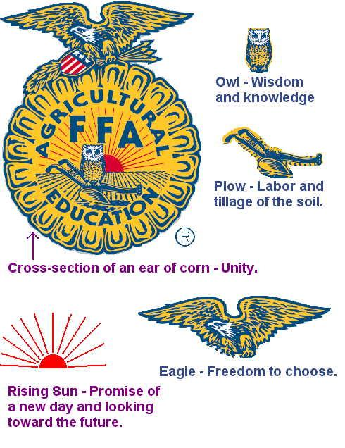
Emblem
Official Dress
The uniform worn by FFA members to local, state and national functions is called official dress. It provides identity and gives a distinctive and recognizable image to the organization and its members.

Official dress for female members:
Black skirt, black dress shoes with a closed heel and toe and black hoisery or slacks with black boots. An official FFA jacket zipped to the top.

Official dress for male members:
Black slacks, a white-collared shirt with official FFA tie, black dress shoes or boots, black socks and an official jacket zipped to the top.

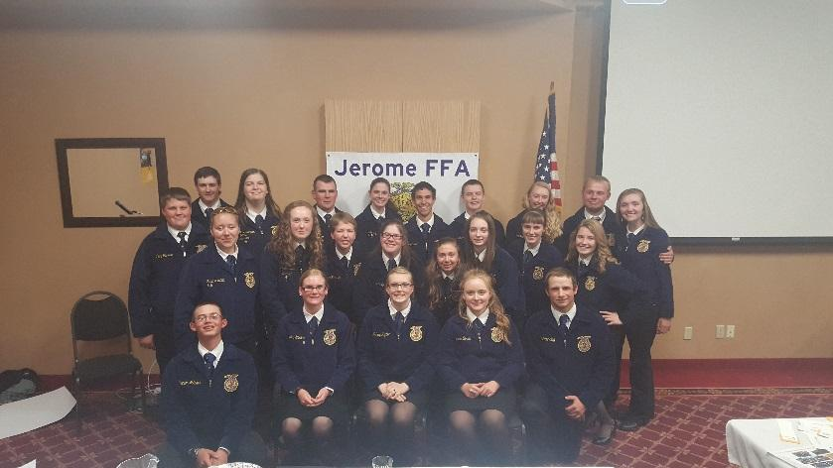
See Mr. Clifton or Mrs. Lebsack to order your FFA jacket today!
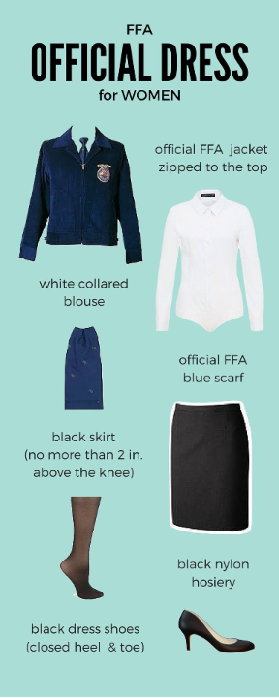

Degree Program
The FFA Degree Program is a system of ranks, or steps, which are designed to assist members in maintaining continuous progression in leadership training and personal development.

Discovery FFA Degree: 8th grade FFA members
Greenhand FFA Degree: 1st year FFA members.
Chapter FFA Degree: 2nd year FFA members.
State Degree: 3rd-4th year FFA members.
American Degree: Obtained 1yr after senior year.

The FFA Degree system is the first pathway towards success which members embark upon, there is not competition against other members. Members must only compete with themselves to accomplish minimum requirements. Degree requirements can be read in the chapter and state constitutions.

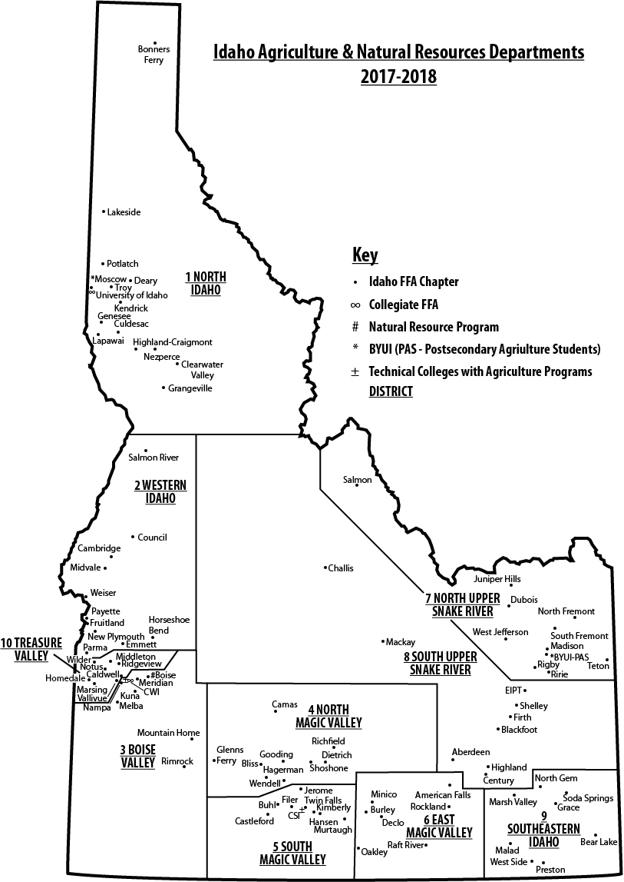
Idaho State Districts
Idaho is divided into nine districts for leadership and CDE purposes. Each district has a District Advisor and District Officers. Jerome is located in the South Magic Valley District.

Calendar of Events
MONTH | DATE | EVENT | LOCATION | TIME
SEPT | 13 | District Social | TBA | 6:00pm
 | TBA | Regional Soils | Jerome | 9:00am
OCT | 11 | State Soils and range | Burley | 9:00am
 | 18 | District Livestock | Fairgrounds | 10:00am
 | 25-28 | Nationals FFA Convention | indianapolis
NOV | 8 | Creed/ Greenhand Ceremonies/job interview | roper auditorium | 6:00pm
DEC | 5-9 | NAAE Convention | nashville
 | 13 | Dairy foods/ Agronomy | CSI | 4:00pm
 | 19 | Bowling Contest | Twin Falls | 6:00pm
 | 3 | Advisor Meeting | CSI | 6:00pm
JAN | 17 | State Degree Test | Jerome | 4:00pm
 | 24 | District Ag Sales | Castleford | 4:00pm
 | 29 | FFA Day on the Hill | Boise
 | 29-30 | 212/360 Leadership Conference | Boise
FEB | 5-6 | 212/360 Leadership Conference | Pocatello
 | 6 | State Degree Sifting | Jerome | 4:00pm
 | 7 | Advisor Meeting | CSI | 6:00pm
 | 15 | District Ag Mech | Buhl | 4:00pm
 | 20-23 | National FFA Week
 | 21 | District Food Science | Kimberly | 4:00pm
MAR | 7 | Advisor Meeting | CSI | 6:00pm
 | 14 | Extemp/Parli/Prepared/  Conduct of Meetings | Jerome | 9:00am
 | 21 | District Horse | CSI | 9:00am
 | 21 | District Floriculture | Kimberly | 4:30pm
APR | 4 | District Dairy | CSI | 12:30pm
 | 4-7 | State Leadership Conference | CSI
 | 18 | District Forestry and ENR | South Hills | 10:00am
MAY | 9 | District Meats | Scarrows | 1:00pm
JUNE | 5-9 | State CDE’s | Moscow

