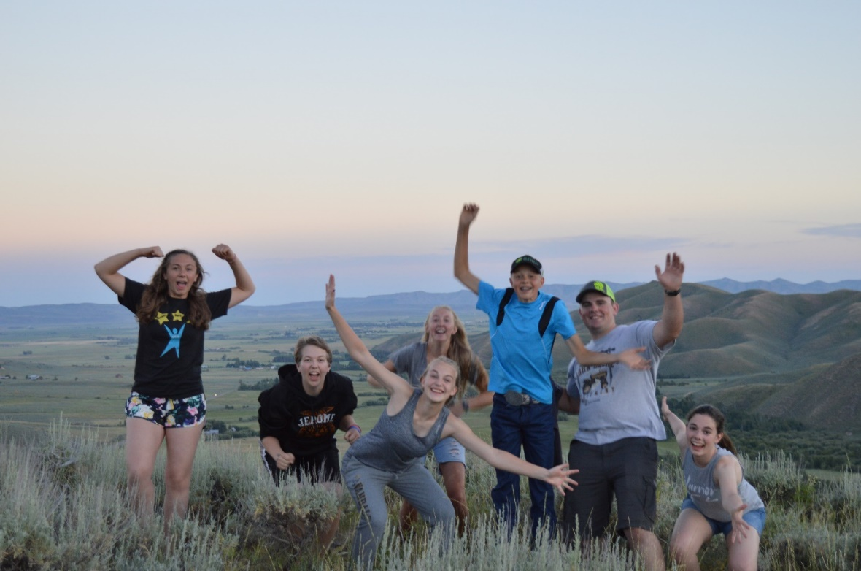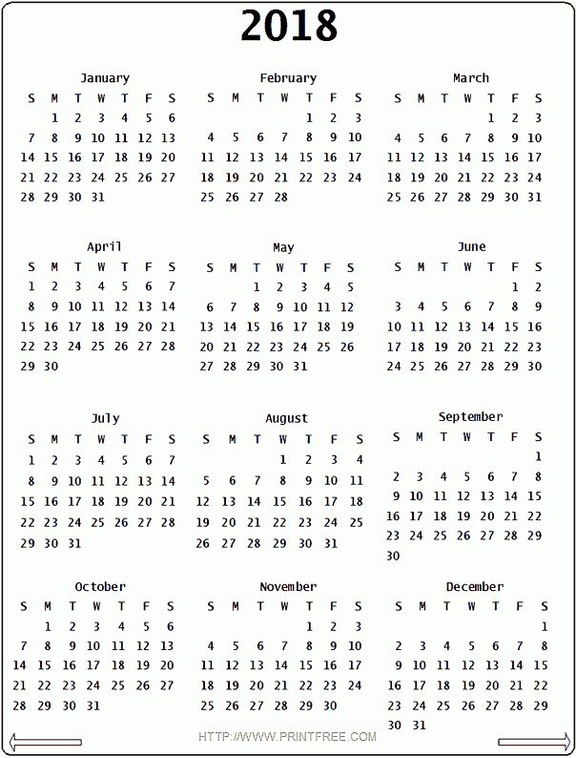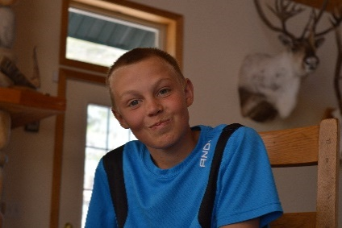

**JHS FFA**

**Chapter Officer POA**

**2017-2018**

**Jan 9th Meeting: Clifton**

*Meat:* Guest Speaker

*Leadership on the Go!:* Annabelle

*Game:* Potato Tower-Adri

*Treat:* Kaitlin

January

**CDE’s:**

24th-Ag Sales-Lebsack

**Activities**

|  |  |  |  |
| --- | --- | --- | --- |
| **Date** | **Event** | **Teacher** | **FFA Officer** |
| **17th** | **State Degree Test** | **Willmore** | **None** |
| **29-30th** | **212/360** | **Clifton** | **None** |

Notes:

Notes:

February

August

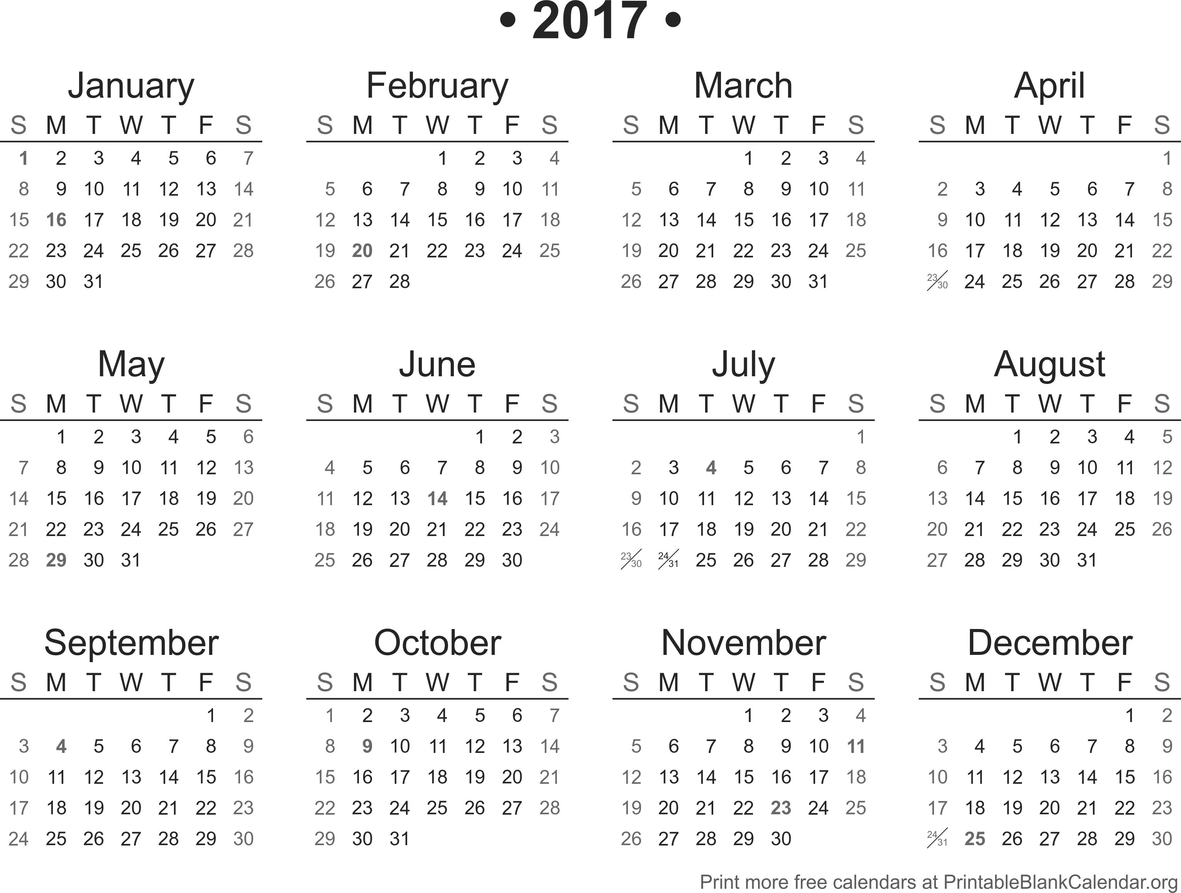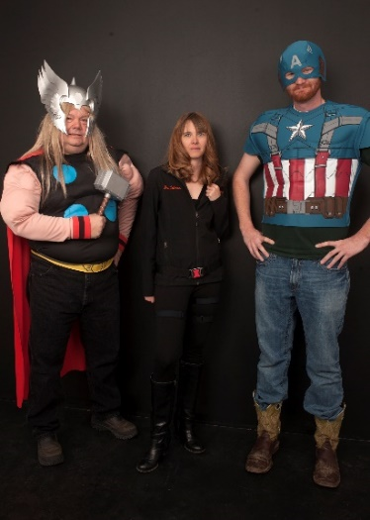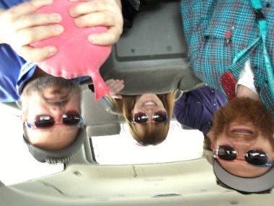

**Activities**

|  |  |  |  |
| --- | --- | --- | --- |
| **Date** | **Event** | **Teacher** | **FFA Officer** |
| **29th** | **Kick Off BBQ** | **Willmore** | **Adri** |
|  | **T-shirts** | **Lebsack** | **Alyssa** |
|  | **Potatoes** | **Lebsack** | **Cody** |

**Feb 6th Meeting: Lebsack**

*Meat:* CDE Workshops

(Floral-Adri/Annabelle, Parli-Kaitlin/Alyssa, Horse-Maddie/Cody, Sales-Troy)

*Leadership on the Go!:* Cody

*Game:* Mittens and Kisses

*Treat:* Maddie

**CDE’s:**

15th-Ag Mechanics-Clifton  
21st-Food Science-Lebsack

**Activities**

|  |  |  |  |
| --- | --- | --- | --- |
| **Date** | **Event** | **Teacher** | **FFA Officer** |
| **1st-3rd** | **AgriAction** | **Willmore** | **Cody** |
| **6th** | **State Degree Sifting** | **Willmore**  **Lebsack** | **None** |
| **20th-22nd** | **Welding Wars** | **Clifton** | **Cody** |
| **20th** | **Muffins for Teachers** | **Lebsack** | **Annabelle** |
| **21st** | **Drive Your Tractor to School** | **Willmore** | **Cody** |
| **22nd** | **Elementary Ed Day** | **Willmore** | **Alyssa** |
| **23rd** | **Kiss the Animal/BBQ** | **Lebsack** | **Kaitlin** |



Notes:

Notes:

**CDE’s:**

15th-Extemp-Lebsack

-Parli-Pro-Clifton

-Prepared-Lebsack  
 -Conduct of Meeting-Lebsack  
21st-Horse Evaluation-Willmore  
21st-Floral Design-Lebsack

**Activities**

|  |  |  |  |
| --- | --- | --- | --- |
| **Date** | **Event** | **Teacher** | **FFA Officer** |
| **8th-10th** | **Industry Tours** | **Willmore**  **Lebsack** | **Alyssa** |
| **31st** | **Easter Egg Hunt** | **Clifton** | **Maddie** |

**Sept 5th Meeting: Clifton**

*Meat:* CDE Workshops

(Soils-Alyssa, Forestry-Kaitlin, Livestock-Maddie)

*Committee Meeting:* Growing Leaders

*Leadership on the Go!:* Adri-Scenario Conversations

*Game:* Junk in the Trunk

*Treat:* Mr. Willmore

**Activities**

|  |  |  |  |
| --- | --- | --- | --- |
| **Date** | **Event** | **Teacher** | **FFA Officer** |
| **5th** | **Greenhand Celebration** | **Lebsack** | **Adri** |
| **5th** | **SMVD Social** | **Willmore** | **Kaitlin** |
| **9th** | **Live History Days** | **Willmore** | **Troy** |
| **16** | **Culvers Day** | **Clifton** | **Alyssa** |
| **22nd** | **Homecoming** | **Lebsack** | **Troy** |

**CDE’s:**

28th-Land and Soil Eval-Clifton

March

**March 6th Meeting: Willmore**

*Meat:* Guest Speaker

*Committee:* 10 min Break

*Leadership on the Go!:* Kaitlin

*Game:* Keys and/or Human Knot-Troy and Alyssa

*Treat:* Cody

September

Notes:

Notes:

April

October



**Activities**

|  |  |  |  |
| --- | --- | --- | --- |
| **Date** | **Event** | **Teacher** | **FFA Officer** |
| **3rd** | **Jerome City Clean-Up** | **Lebsack** | **Annabelle** |
| **4-7th** | **SLC** | **All** | **All** |

**CDE’s:**

18th-Livestock Eval-Willmore

**Oct 3rd Meeting: Lebsack**

*Meat:* Guest Speaker

*Committee Meeting:* Strengthening Ag

*Leadership on the Go!:* Alyssa-Treasure Hunt

*Game:* Hoop Around the Circle

*Treat:* Mrs. Lebsack

**Activities**

|  |  |  |  |
| --- | --- | --- | --- |
| **Date** | **Event** | **Teacher** | **FFA Officer** |
| **5-7th** | **UI Ag Days** | **Willmore** | **None** |
| **21st-29th** | **National Conference** | **Lebsack** | **None** |
| **30th** | **Haunted Swamp** | **Clifton** | **Troy** |

**CDE’s:**

18th-Forestry-Lebsack

-ENR-Lebsack

**April 3rd Meeting: Clifton**

*Meat:* Guest Speaker-Don Scarrow

*Committee Meeting:* 10 min break

*Leadership on the Go!:* Troy

*Game:* Egg Toss-Mrs. Lebsack

*Treat:* Alyssa

Notes:

Notes:

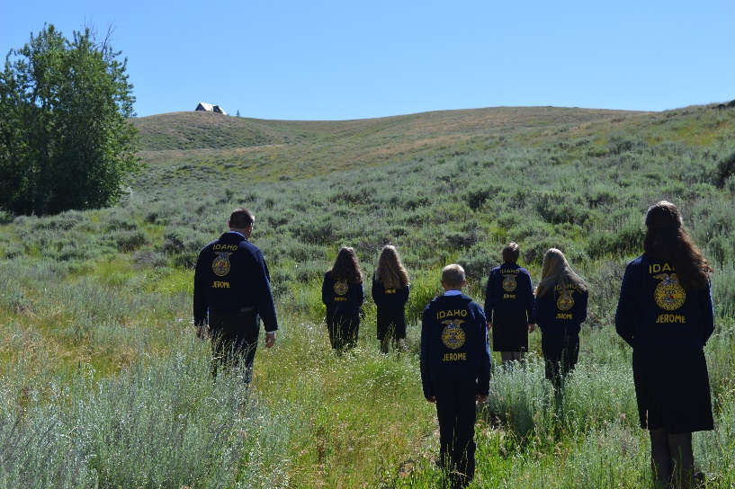

November

**CDE’s:**

9th-Meats-Willmore

**CDE’s:**

8th-Creed-Lebsack

-Greenhand-Lebsack

-Job Interview-Clifton

-Opening/Closing-Willmore

**Nov 7th Meeting-Willmore**

*Meat:* CDE Workshop

(Food Sci-Alyssa, Dairy Foods-Annabelle, Agronomy-Adri, Mech-Cody)

*Committee Meeting:* Bldg Communities

*Leadership on the Go!:* Maddi-Star Power

*Game:* Rock, Paper, Scissors

*Treat:* Adri

**Activities**

|  |  |  |  |
| --- | --- | --- | --- |
| **Date** | **Event** | **Teacher** | **FFA Officer** |
| **7th** | **Scholarship Night** | **Lebsack** | **Adri** |
| **16th** | **FFA Thanksgiving** | **Lebsack** | **Annabelle** |

May

**Activities**

|  |  |  |  |
| --- | --- | --- | --- |
| **Date** | **Event** | **Teacher** | **FFA Officer** |
| **8th** | **FFA Banquet** | **All** | **Adri** |
| **15th** | **Mini-Golf** | **Lebsack** | **Troy** |

Notes:

Notes:

June

December

**Activities**

|  |  |  |  |
| --- | --- | --- | --- |
| **Date** | **Event** | **Teacher** | **FFA Officer** |
| **2nd** | **Sunset Memorial** | **Willmore** | **Adri** |
| **9th** | **Breakfast w/Santa** | **Clifton** | **Maddie** |
| **16th** | **Culver’s Santa** | **Lebsack** | **Kaitlin** |
| **19th** | **Christmas Party** | **Willmore** | **Mddie** |
| **18th-22nd** | **Rotary Baskets** | **Lebsack** | **Annabelle** |

**Activities**

|  |  |  |  |
| --- | --- | --- | --- |
| **Date** | **Event** | **Teacher** | **FFA Officer** |
| **3rd-9th** | **State CDE’s** | **All** | **None** |
| **TBA** | **NW Farm Credit Golf** | **Clifton** | **Maddie** |
| **TBA** | **Officer Retreat** | **Lebsack** | **None** |
| **30th** | **Freedom Fest** | **Willmore** | **Kaitlin** |



**CDE’s:**

13th-Dairy Foods-Clifton  
 -Agronomy-Lebsack

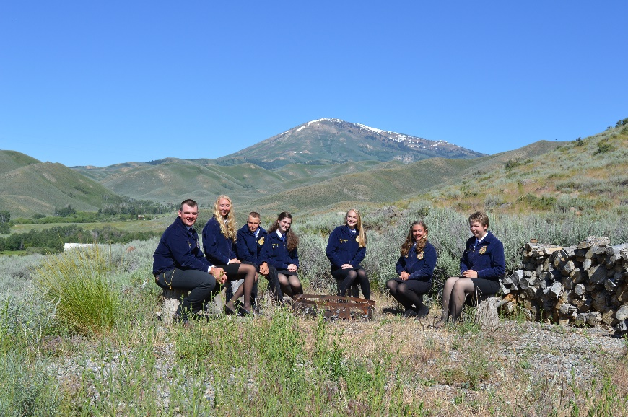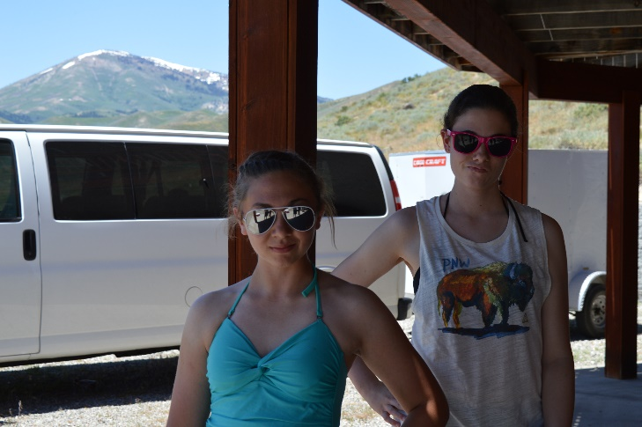

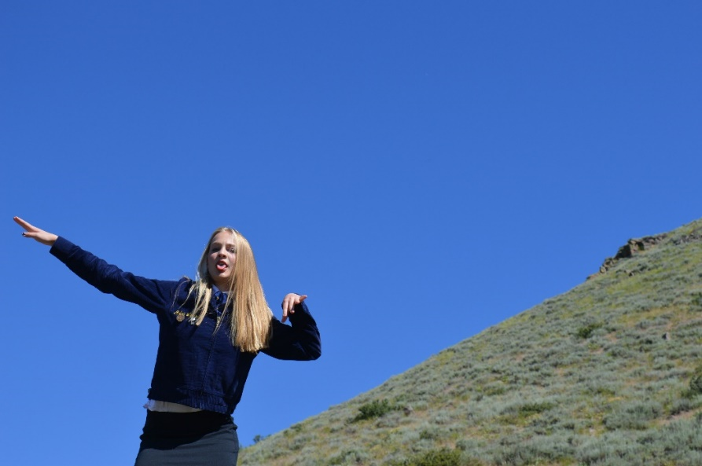

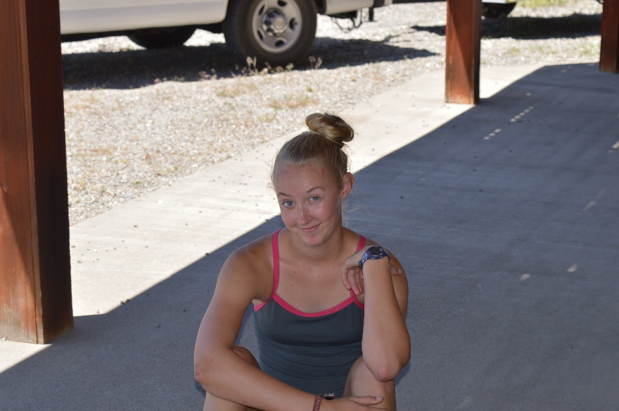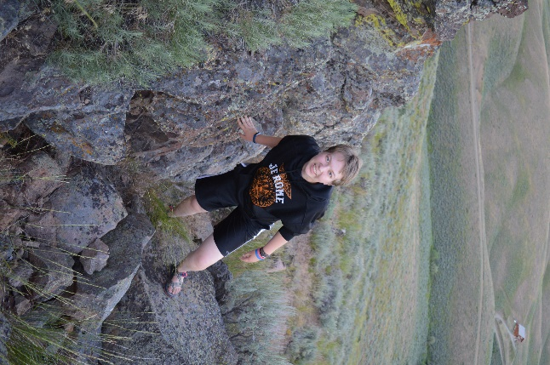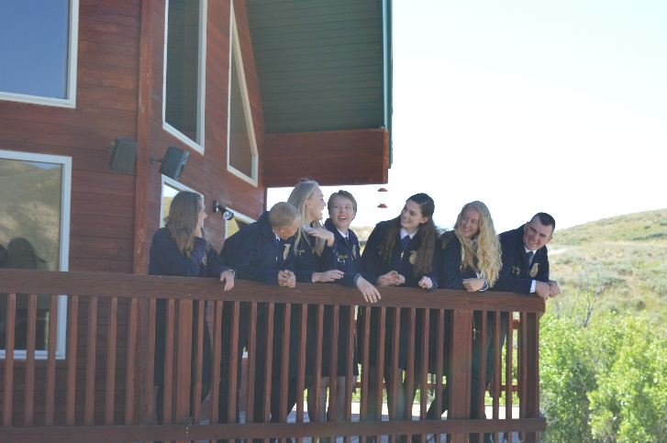

Notes: