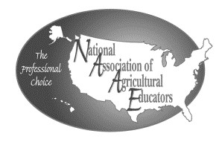

201
8

Idaho NAAE Ideas Unlimited Award

Application

Form/
Cover Sheet
s

Name of Applicant:
School Name:

City:
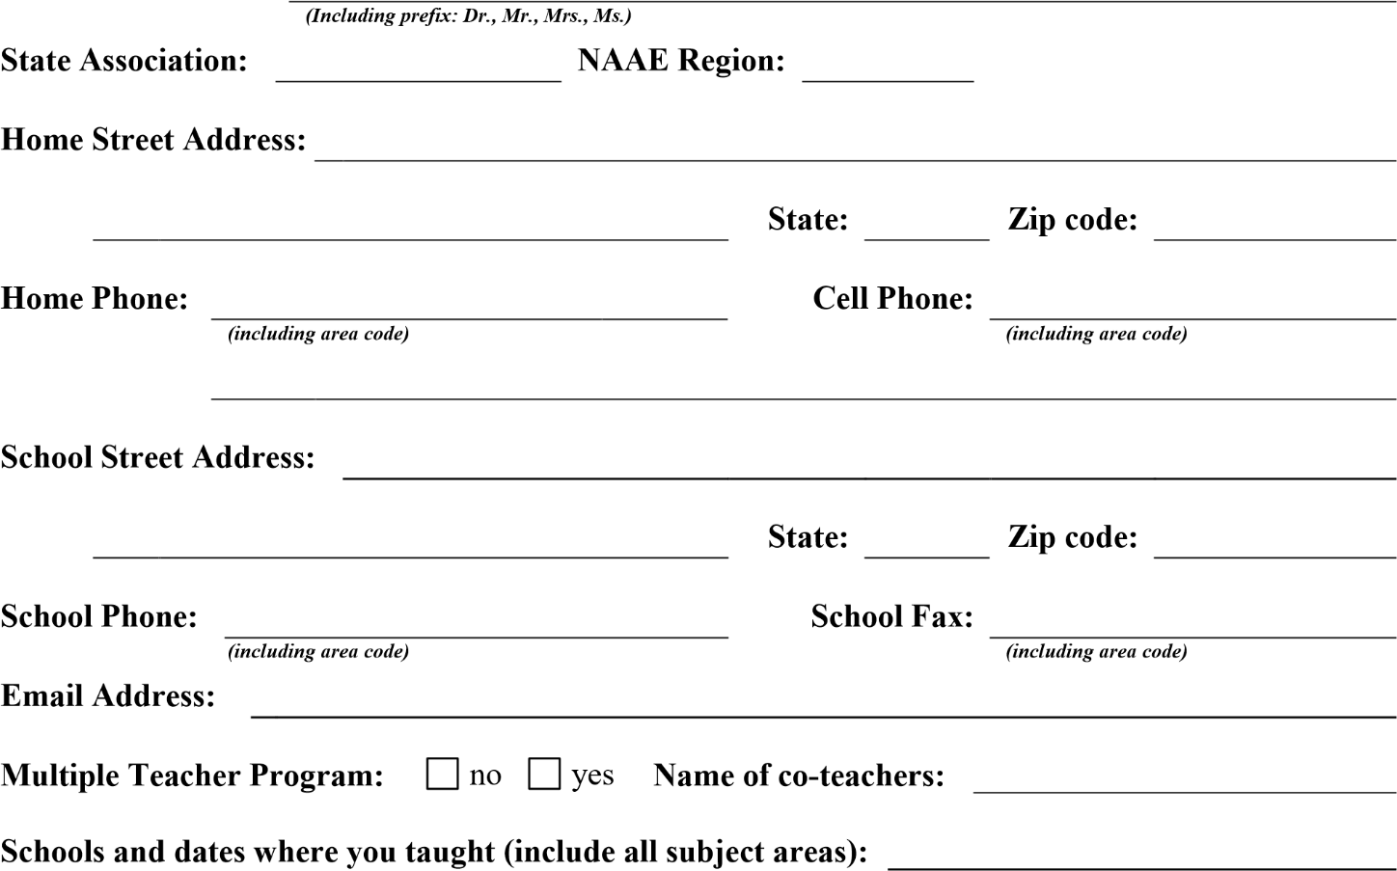
Application Checklist:
Checklist should be used by applicant and state president to insure that each application is complete and meets eligibility requirements.

Applicant has been an active NAAE member for three (3) previous years or continuously since he/she began teaching.

Applicant has paid their 2016-2017 NAAE Active membership dues. Applicant’s dues have been submitted to NAAE by state dues remitter.
Application is complete and includes NAAE cover sheet, narrative portion, supporting materials and an application signature sheet.
Application signature form provided by NAAE includes signature of applicant and school official.
Application is typed in no smaller than 12 point font, and is double-spaced.
Narrative of application does not exceed three 8 1/2” x 11” pages.
Supporting materials does not exceed three 8 1/2” x 11” pages.

Cover Page 2 of 2 NAAE Award Application Signature Page
Please read below and provide the appropriate signatures. You must provide this page as part of the submission of your application.

Photograph License & Publicity Release

By submitting and signing this application, the applicant hereby agrees to the following terms and conditions regarding any photographs submitted to NAAE as supporting materials for such application.
License – By submitting any photographs to NAAE with this application, applicant hereby grants to NAAE a fully paid, perpetual, irrevocable, royalty free, world-wide non-exclusive license to display, distribute, sublicense, reproduce, modify, adapt and publish such photographs on
NAAE’s website and in any other materials used to promote NAAE.
Consent & Authorization – Applicant hereby irrevocably consents and authorizes NAAE, and its successors and assigns, to use any photographs submitted with this application for the purpose of promoting NAAE. Applicant further hereby releases NAAE, and its officers, directors, agents, members, employees, successors and assigns, from any and all claims for damages for libel, infringement of the right of publicity, invasion of privacy, portrayal in a false light, or any other claim based on the use of any photographs submitted with this application.
Representations & Warranties – Applicant hereby represents and warrants that he/she has the power and authority to grant the rights licensed to NAAE in this application and that the use, copying, distributing, displaying, reproducing, modifying, adapting, and sublicensing of any photographs submitted with this application does not result in the infringement of any copyright, trademark, patent, or other intellectual property right of another. Applicant further represents and warrants that he/she has obtained the consent and authorization for the use of any photographs submitted with this application from all persons shown in such photographs or from the guardian of any persons under the age of eighteen (18) shown in such photographs.
Indemnification – Applicant hereby indemnifies and holds harmless NAAE, and its officers, directors, agents, members, employees, successors and assigns from any loss, liability, claim or
demand, including reasonable attorney’s fees, made by any third party due to or in any way relating to the use of any photographs submitted with this application or any breach of any of the representations and warranties contained in this application.

If named as an Ideas Unlimited award winner, I will attend and participate in the NAAE Convention. Also, by signing this I agree to the Photograph License & Publicity Release above.

Signed: _____________________________________ Date: ________________________
Applicant’s Signature

